**TP-17**

**A Project Report On**

By Semester 6th of 3rd Year

M.Sc. (2016-2017)

Submitted By :- **Mistry Disha (3193)**

**Shah Harnisha (3226)**

**Shah Jeni (3228)**

Internal Project Guide : - **Hitesh Parmar**

Company Name : - **Tahuko Events and Catering**

Date of Submission :- **20th-April-2017**

Submitted To : -

**K.S.School Of Business Management,**

**M.Sc. In Computer Application and Information Technology,**

**Gujarat University.**



**TAHUKO EVENTS & CATERING**

A/203, SILVER BROOKE BUILDING, SECOND FLOOR, OPP. CLARIS HOUSE,NR.PARIMAL GARDER, AMBAWADI,A’BAD-9.

MOBILE NO.9913055577.9016055577

“This is to certify that Miss Disha Mistry has successfully completed the project on The Wedding Planners under me. This work is original and has not been submitted elsewhere.”

Thanking You,

Your Sincerely,

Mayur Gandhi,

Owner at TAHUKO EVENTS & CATERING

Date: 18/4/2017

**TAHUKO EVENTS & CATERING**

A/203, SILVER BROOKE BUILDING, SECOND FLOOR, OPP. CLARIS HOUSE,NR.PARIMAL GARDER, AMBAWADI,A’BAD-9.

MOBILE NO.9913055577.9016055577

“This is to certify that Miss Harnisha Shah has successfully completed the project on The Wedding Planners under me. This work is original and has not been submitted elsewhere.”

Thanking You,

Your Sincerely,

Mayur Gandhi,

Owner at TAHUKO EVENTS & CATERING

Date: 18/4/2017

**TAHUKO EVENTS & CATERING**

A/203, SILVER BROOKE BUILDING, SECOND FLOOR, OPP. CLARIS HOUSE,NR.PARIMAL GARDER, AMBAWADI,A’BAD-9.

MOBILE NO.9913055577.9016055577

“This is to certify that Miss Jeni Shah has successfully completed the project on The Wedding Planners under me. This work is original and has not been submitted elsewhere.”

Thanking You,

Your Sincerely,

Mayur Gandhi,

Owner at TAHUKO EVENTS & CATERING

Date: 18/4/2017

**Acknowledgement**

The success and final outcome of this project required a lot of guidance and assistance from many people and we are extremely fortunate to have got this all along the completion of our project work. Whatever we have done is only due to such guidance and assistance and we would not forget to thank them.

We respect and thankful to K.S.S.B.M., for giving us an opportunity to do the project work in pHp & Angular2 and providing us all support and guidance which made us completes the project on time. We are extremely grateful to him for providing such a nice support and guidance though he had busy schedule managing the company affairs.

We would like to express our gratitude towards Course coordinator Department, **Dr. Kalyani Patel** and Director,

**Dr. Savita Gandhi** for their kind co-operation and encouragement, which help us in this project.

**Group Id : - 47**

**Mistry Disha (3193)**

**Shah Harnisha (3226)**

**Shah Jeni (3228)**

|  |  |  |  |
| --- | --- | --- | --- |
|  |  |  |  |

**Index**

|  |  |  |  |
| --- | --- | --- | --- |
| Sr. No |  | Title | Page No. |
|  |  | **Introduction** | **7** |
| **1** |  | **Company Profile** | **8** |
| **2** |  | **Project Profile** | **9** |
|  | **2.1** | **Current System** | **10** |
|  | **2.2** | **Proposed System** | **11** |
|  |  |  |  |
| **3** |  | **Tools And Platforms Used** | **12** |
|  | **3.1** | **Gantt Chart** | **13** |
| **4** |  | **System Flow Diagram** | **14** |
| **4** |  | **UML Diagrams** | **15** |
|  | **4.1** | **Use Case** | **15** |
|  | **4.2** | **Class Diagram** | **17** |
|  | **4.3** | **Sequence Diagram** | **18** |
|  | **4.4** | **Activity Diagram** | **19** |
| **5** |  | **DataDictionary** | **20** |
| **6** |  | **Input/Output Design** | **26** |
| **7** |  | **Validation** | **73** |
| **8** |  | **Maintenance** | **76** |
| **9** |  | **Future Scope** | **77** |
|  |  | **Bibliography** | **78** |

Introduction

**Online Wedding Planning** System is a web based project which act as a bridge between potential users and wedding planners. As people spend lots of money on Weddings, Parties and MICE, but they involve their selves in each and every affair in such a way that at the end of the day they feel that they have not seen the wedding of their only Son/Daughter or they have not been able to enjoy the functions. That is why, a Wedding Planner-Co-coordinator is required to make people comfortable on the day of the Wedding /Event.

So that I have tried to make a web project so that all the plannings for the food, venues, invitation cards, bookings can be done on time. This project is developed to make the users comfortable to enjoy each and every function along with their family, friends and relatives. This project organizes :

* Venues & Accommodation.
* Sets, Themes, Concepts & Decorations
* Menu Planning, F & B and Bar Tendering Services.
* Music & Entertainment. Wedding Jaimala Themes.
* Photography: Still & Video.
* Rental Services Like: Security, Hostesses, Travel & Transport, Royal Procession, Fireworks.
* Wedding and Hospitality Management.

**Company Profile**

Company Name : - **Tahuko**

Address : - **A/203, Silver Brook**

**Building, 2nd Floor,**

**Opp. Claris House,**

**Nr. Parimal Garden,**

**Ambavadi, Ahmedabad-09**

Contact No : - **9913055577**

Web Site :- [**www.TahukoCultural Group&EventManagement.com**](http://www.justdial.com/Ahmedabad/Tahuko-Cultural-Group-And-Event-Management-%3Cnear%3E-Opposite-Doctor-House-Near-Parimal-Crossing-Ellis-Bridge/079PXX79-XX79-130719141550-Y5T6_BZDET)



**Project Profile**

Project Title : - **Wedding Planners**

Team Size **: - 3**

Developers : - **Mistry Disha**

**Shah Harnisha**

**Shah Jeni**

Time Duration : - **6 Months**

Basic

Requirements : - **Android Device**

**Desktop/ Laptop**

**Internet Connection**

Current System

The existing system is manual /machine systems where the users must have to perform their manually. It will take more

time and this whole procedure is very tedious and takes a lot of time.

Problems of the existing system

* It is limited to a single system.
* It has lot of manual work (Manual work does not mean working with pen or paper, rather includes working on spread sheets and other simple software.)
* The present system is very less secure.
* It unable to generate different kinds of reports.
* It is difficult to maintain phone bookings and cancellations.
* Does not provide global support. User cannot do the reservation from remote place.
* Retrieval of information is difficult and time consuming.
* A lot of time and manual effort is required

Proposed System

1. Data backup facility will be introduced.

2.Graphical richness is required for the more user interactivity.

Tools And Platforms Used

**Tools:-**

|  |  |
| --- | --- |
| **Number** | **Description** |
| 1 | Pantium micro processor with 40GB Hard-Disk and 512 MB RAM |

**Platforms:-**

**Platform:** PHP

**Fronted:** Sublime or

Visual studio code

**Back end:** My SQL

Node.js

**Tools:** JQuery

Google Map API

**Web service**: JSON

Gantt Chart

|  |  |  |  |  |  |  |
| --- | --- | --- | --- | --- | --- | --- |
| **Activities** | **Dec** | **Aug** | **Sep** | **Oct** | **Nov** | **Dec Jan Feb March** |
| Project Sope |  |  |  |  |  |  |
| Research |  |  |  |  |  |  |
| ––––Requirement Gathering |  |  |  |  |  |  |
| Analysis |  |  |  |  |  |  |
| Designing |  |  |  |  |  |  |

|  |  |  |  |  |  |  |  |
| --- | --- | --- | --- | --- | --- | --- | --- |
| Coding |  |  |  |  |  |  | |
| Testing |  |  |  |  |  | |  |

System Flow Diagram

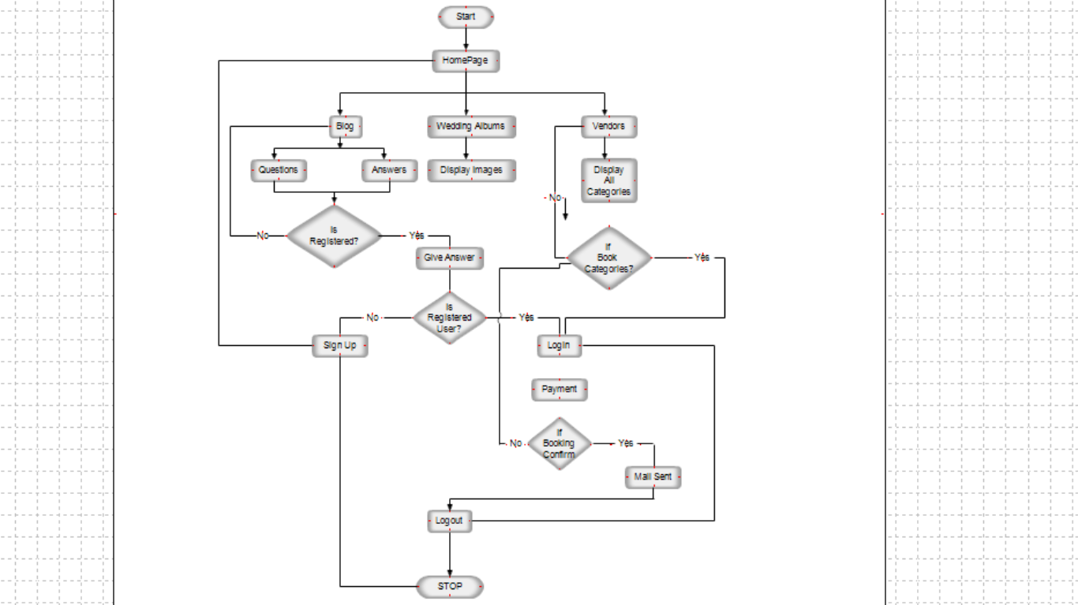

UML Diagrams

**[1.1] Use Case Diagram**

Symbols Used In Use Case Diagram

|  |  |
| --- | --- |
| 1. Actor |  |
| 1. Use Case |  |

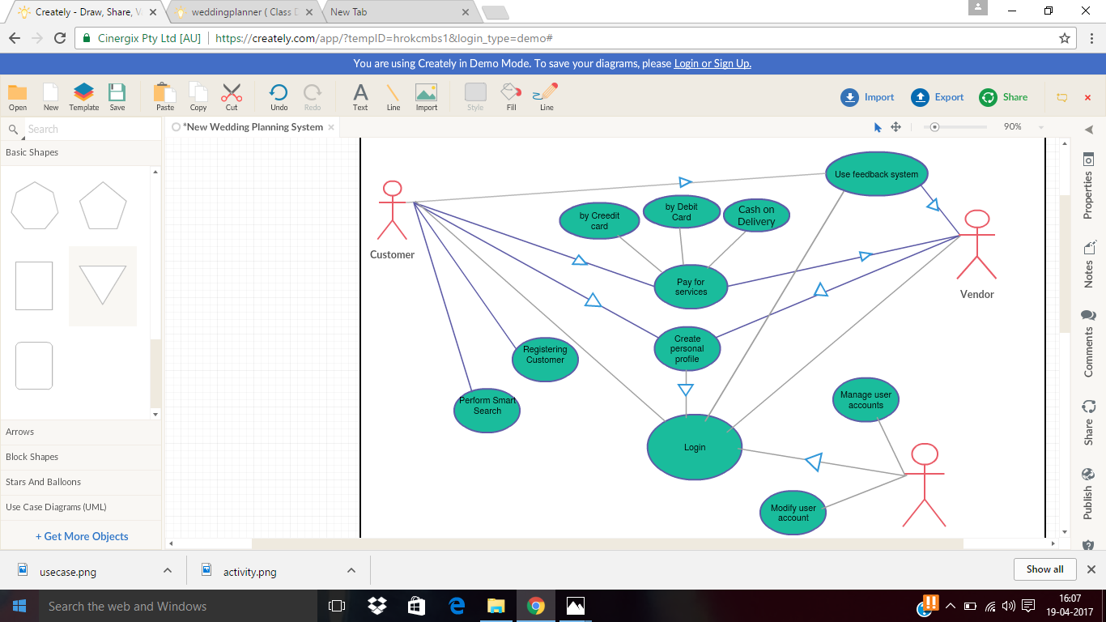

**[1.2] Class Diagram**

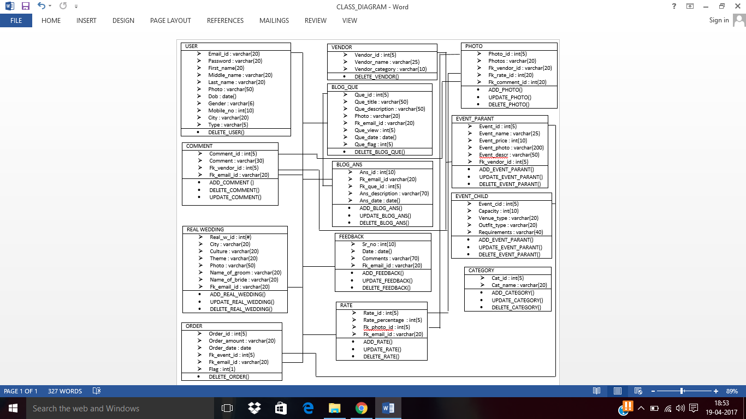

**[1.3] Sequence Diagram-**

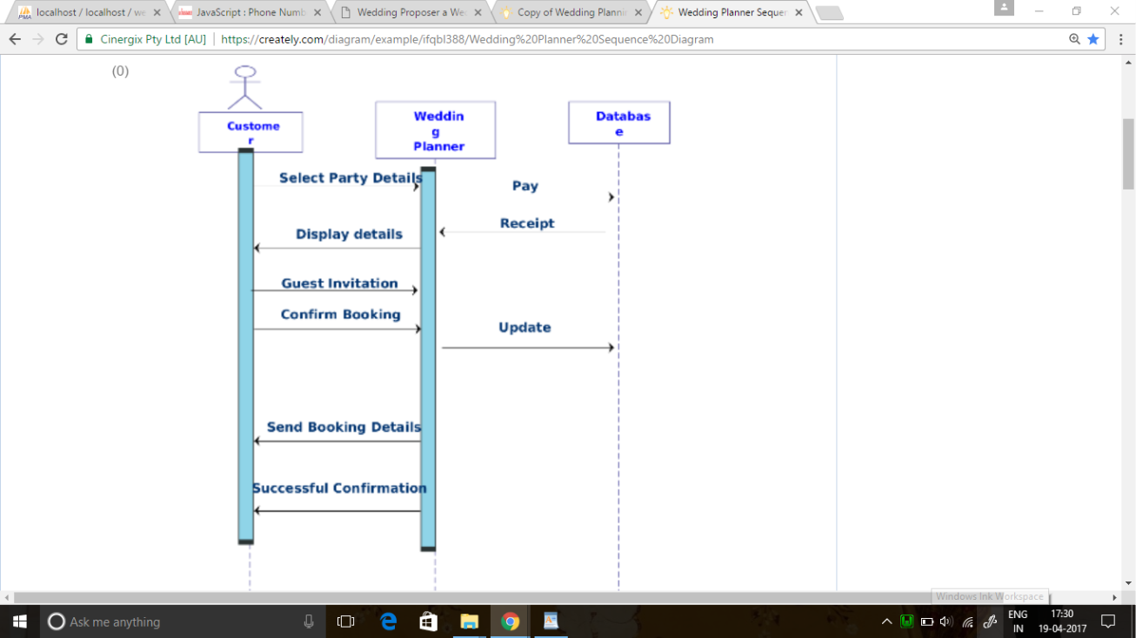

**[1.4] Activity Diagram**

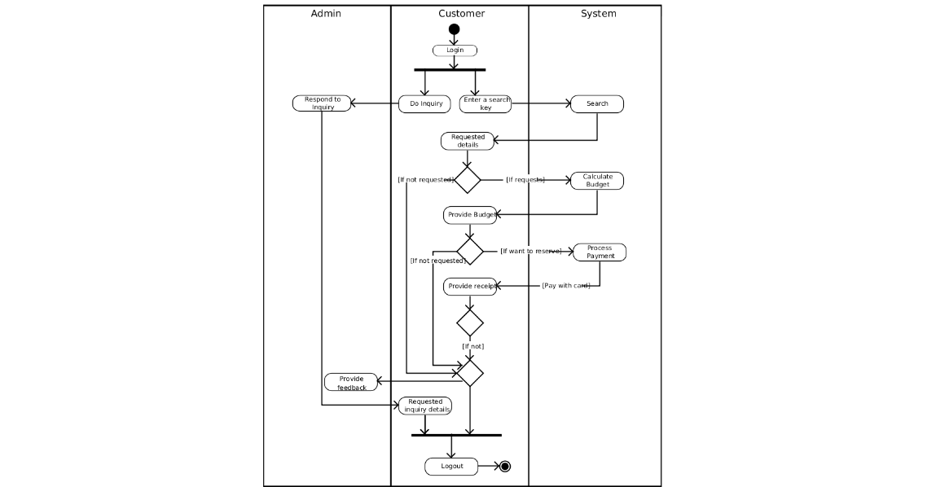

Data Dictionary

|  |  |  |
| --- | --- | --- |
|  | **user table** |  |
| **Column1** | **Column2** | **Column3** |
| email_id | varchar(20) | primary key |
| password | varchar(20) |  |
| first_name | varchar(20) |  |
| middle_name | varchar(20) |  |
| last_name | varchar(20) |  |
| photo | varchar(50) |  |
| dob | date |  |
| gender | varchar(6) |  |
| mobile_no | int(10) |  |
| city | varchar(20) |  |
| type | varchar(5) |  |

|  |  |  |
| --- | --- | --- |
|  | **vendor table** |  |
| **Column1** | **Column2** | **Column3** |
| vendor_id | int(5) | primary key |
| vendor_name | varchar(25) |  |
| vendor_category | varchar(10) |  |

|  |  |  |  |  |  |  |
| --- | --- | --- | --- | --- | --- | --- |
|  | **order table** | |  | |  | |
| **Column1** | **Column2** | | **Column3** | |  | |
| order_id | int(5) | | primary key | |  | |
| order amount | Varchar(20) | |  | |  | |
| order date | Date | |  | |  | |
| fk_event_id | Int(5) | | Foreign key | |  | |
| fk_email_id | Varchar(20) | | Foreign key | |  | |
| flag | int(1) | |  | |  | |
|  | | **event_paranttbl** | |  | |
| **Column1** | | **Column2** | | **Column3** | |
| event_id | | int(5) | | primary key | |
| event_name | | varchar(25) | |  | |
| event_price | | int(10) | |  | |
| event_photo | | varchar(200) | |  | |
| event_description | | varchar(50) | |  | |
| fk_vendor_id | | int(5) | | Foreign key | |
|  | |  | |  | |
|  | | **event child table** | | | |
|  | |  | |  | |
| event_cid | | int(5) | | primary key | |
| capacity | | int(10) | |  | |
| venue_type | | varchar(20) | |  | |
| outfit_type | | varchar(20) | |  | |
| requirements | | varchar(40) | |  | |

|  |  |  |
| --- | --- | --- |
|  | **category tbl** |  |
| **Column1** | **Column2** | **Column3** |
| cat_id | int(5) | primary key |
| cat_name | varchar(20) |  |

|  |  |  |
| --- | --- | --- |
|  | **comment_tbl** |  |
| **Column1** | **Column2** | **Column3** |
| comment_id | int(5) | primary key |
| comment | varchar(30) |  |
| fk_vendor_id | int(5) | Foreign key |
| fk_email_id | varchar(20) | Foreign key |

|  |  |  |
| --- | --- | --- |
|  | **feedback_tbl** |  |
| **Column1** | **Column2** | **Column3** |
| sr_no | int(10) | primary key |
| date | date |  |
| comments | varchar(70) |  |
| fk_email_id | varchar(20) | Foreign key |

|  |  |  |
| --- | --- | --- |
|  | **gallery table** |  |
| **Column1** | **Column2** | **Column3** |
| photo_id | int(5) | primary key |
| photos | varchar(20) |  |
| fk_vendor_id | int(5) | Foreign key |
| fk_rate_id | Int(20) | Foreign key |
| fk_comment_id | Int(20) | Foreign key |

|  |  |  |
| --- | --- | --- |
|  | **rate table** |  |
| **Column1** | **Column2** | **Column3** |
| rate_id | int(5) | primary key |
| rate _percentage | int(5) |  |
| fk_photo_id | int(5) | Foreign key |
| fk_email_id | varchar(20) | Foreign key |

|  |  |  |
| --- | --- | --- |
|  | **Real wedding table** |  |
| **Column1** | **Column2** | **Column3** |
| real_w_id | int(3) | primary key |
| city | varchar(20) |  |
| culture | varchar(20) |  |
| theme | varchar(20) |  |
| photo | varchar(50) |  |
| name_of_groom | varchar(20) |  |
| name_of_bride | varchar(20) |  |
| wedding_place | varchar(20) |  |
| fk_email_id | Varchar(20) |  |

|  |  |  |
| --- | --- | --- |
|  | **blog_ans_tbl** |  |
| **Name** | **Column2** | **Column3** |
| ans_id | int(10) | primary key |
| fk_email_id | varchar(20) | Foreign key |
| fk_que_id | int(5) | Foreign key |
| ans_description | varchar(70) |  |
| ans_date | date |  |

|  |  |  |
| --- | --- | --- |
|  | **blog_que_tbl** |  |
| **Column1** | **Column2** | **Column3** |
| que_id | int(5) | primary key |
| que_title | varchar(50) |  |
| que_description | varchar(50) |  |
| photo | Varchar(20) |  |
| fk_email_id | varchar(20) | Foreign key |
| que_view | int(5) |  |
| que_date | date |  |
| que_flag | int(5) |  |

Input/Output Design

Admin

**[1] User Page**

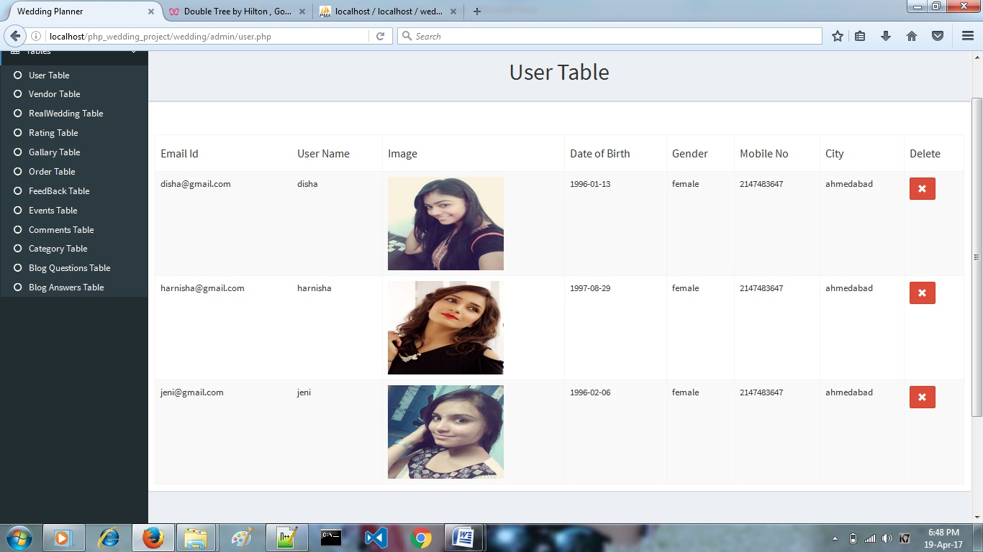

**[2] Edit Profile**

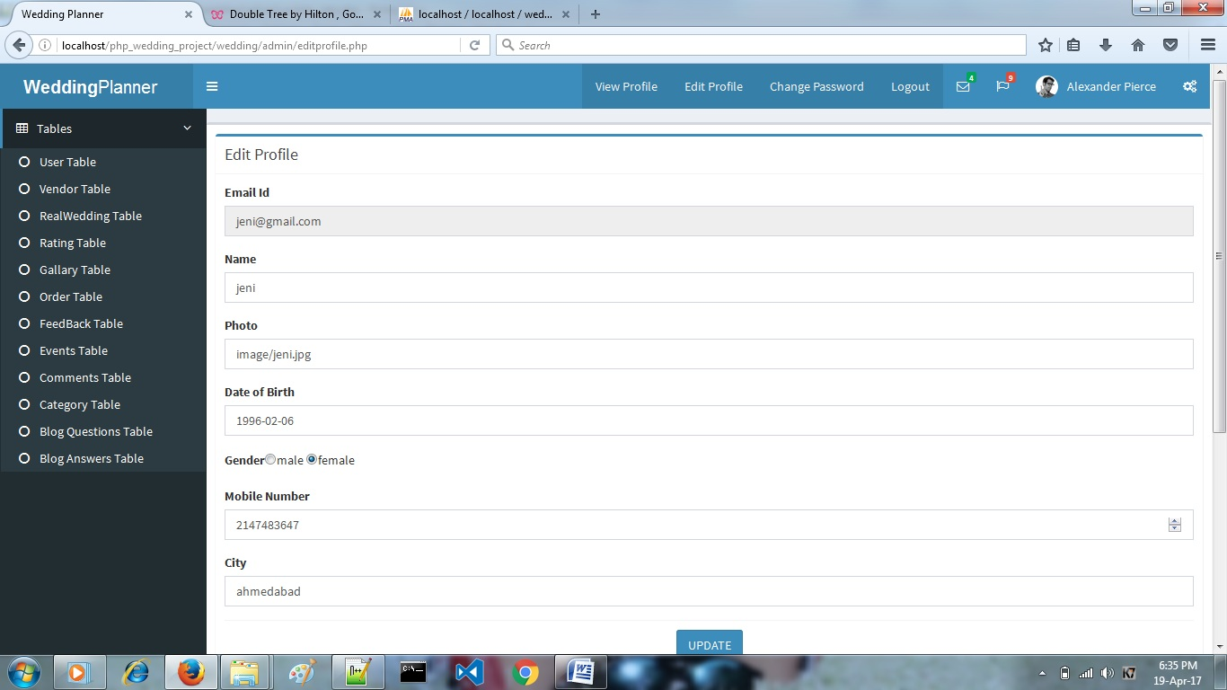

**[3] Change Password**

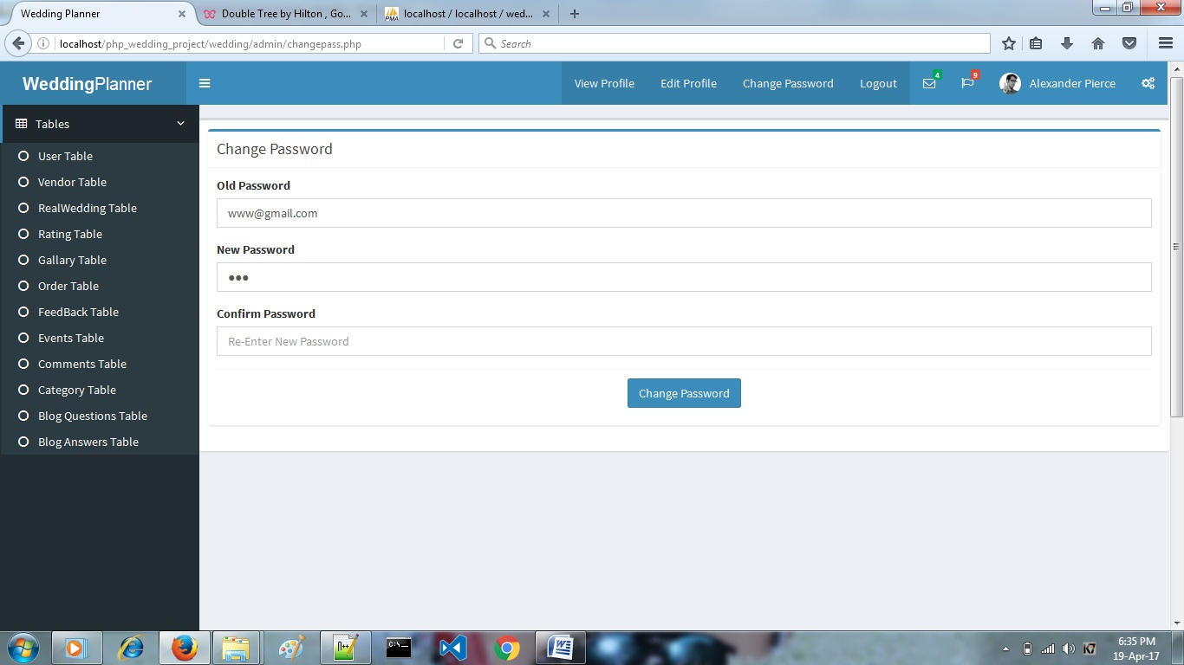

**[4] Vendors Page**

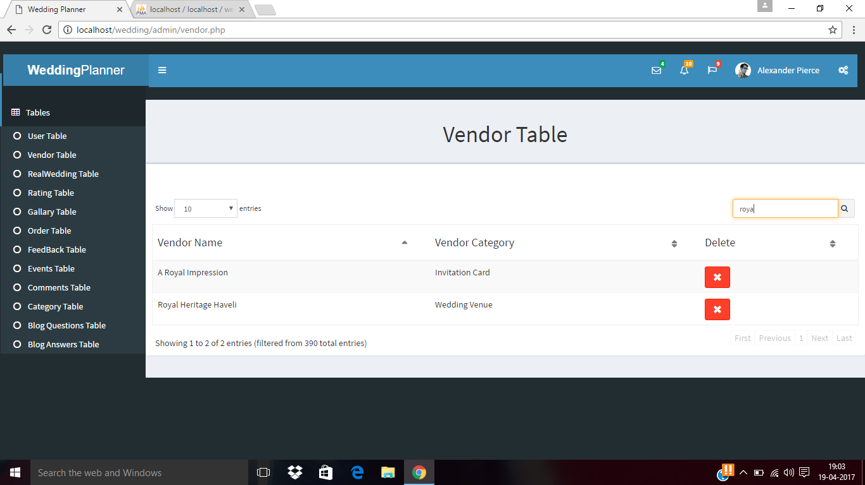

**[5] Real Wedding Page**

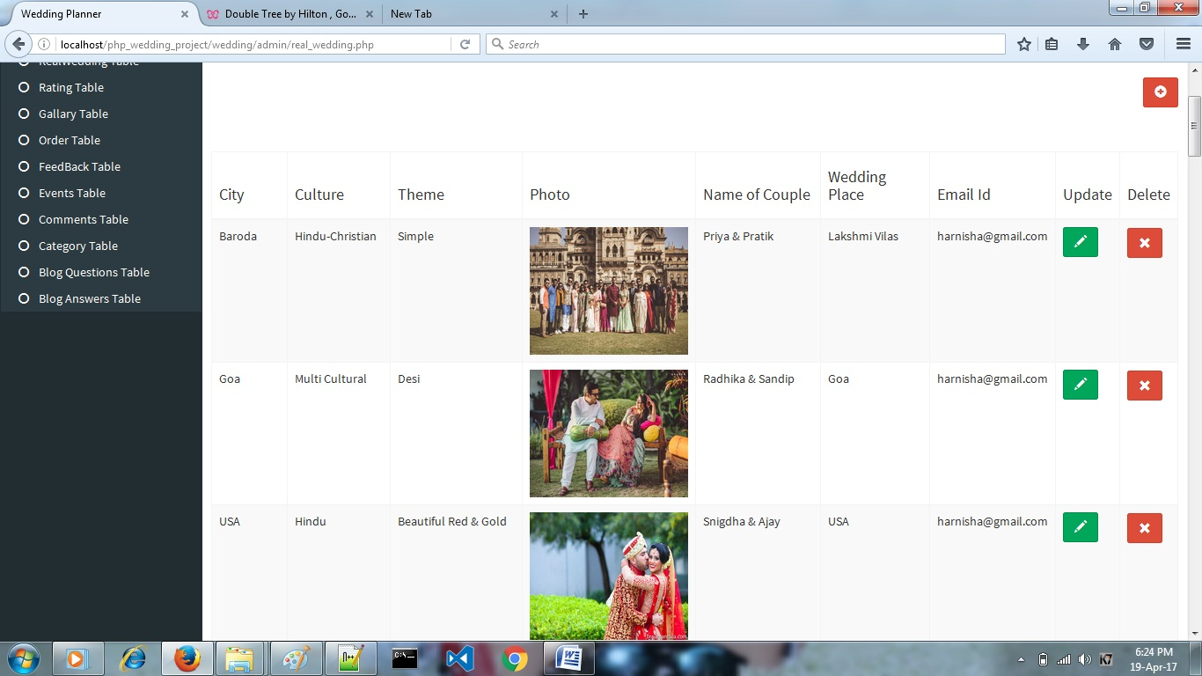

**[6] Real Wedding Insert Page**

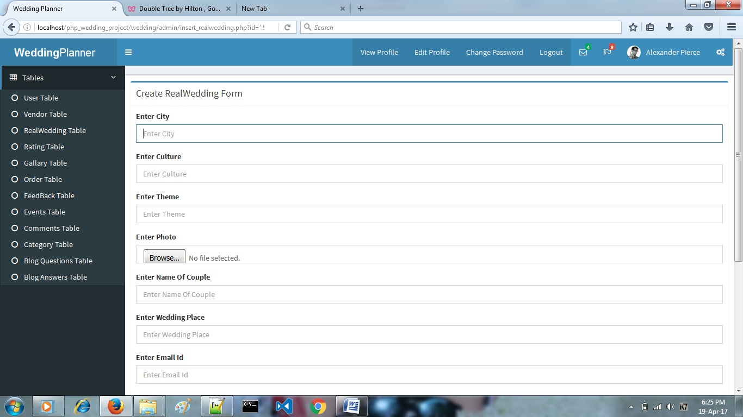

**[7] Real Wedding Insert Page**

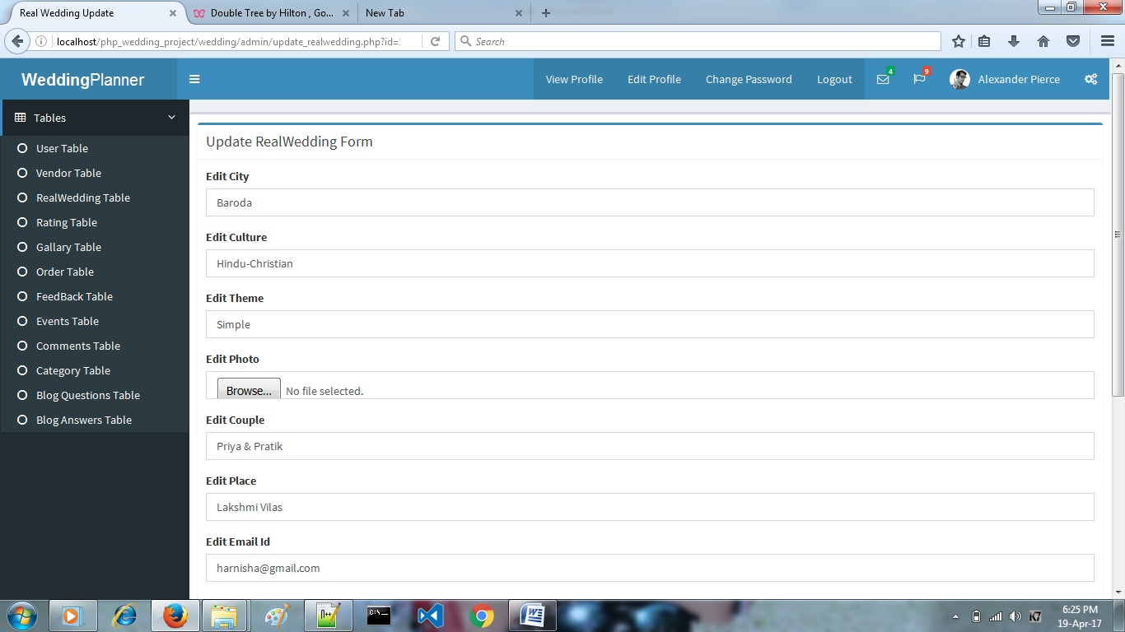

**[8] Rating Page**

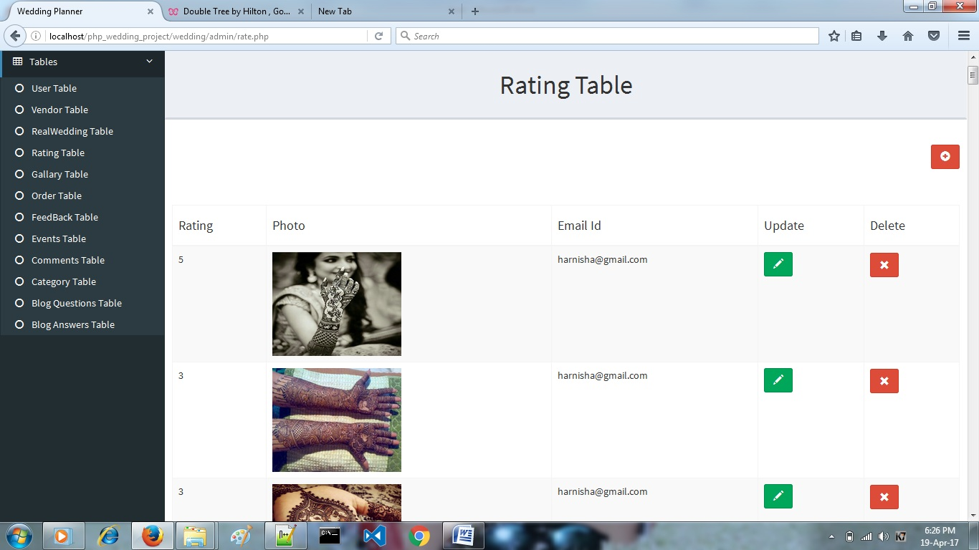

**[9] Gallary Page**

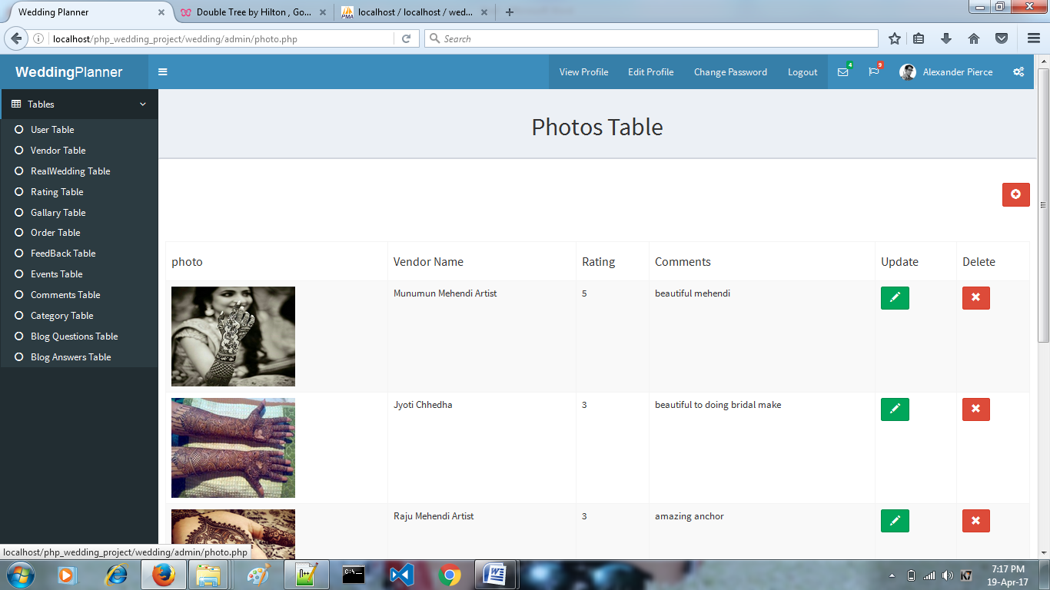

**[10] Order Page**

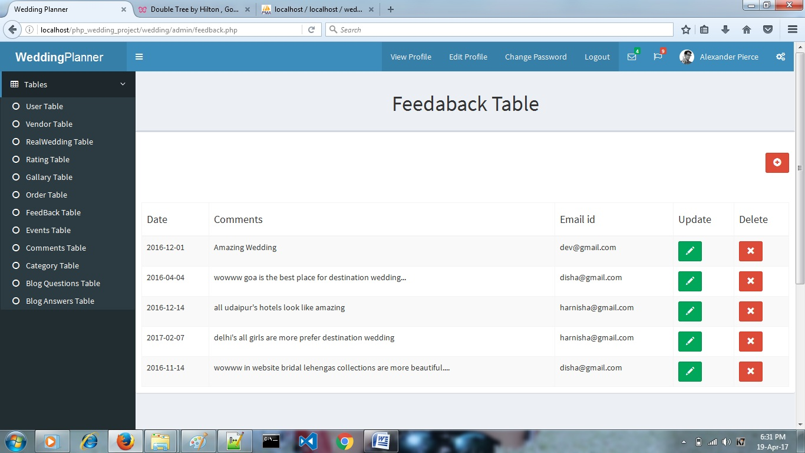

**[11] Feedback Page**



**[12] Events Page**

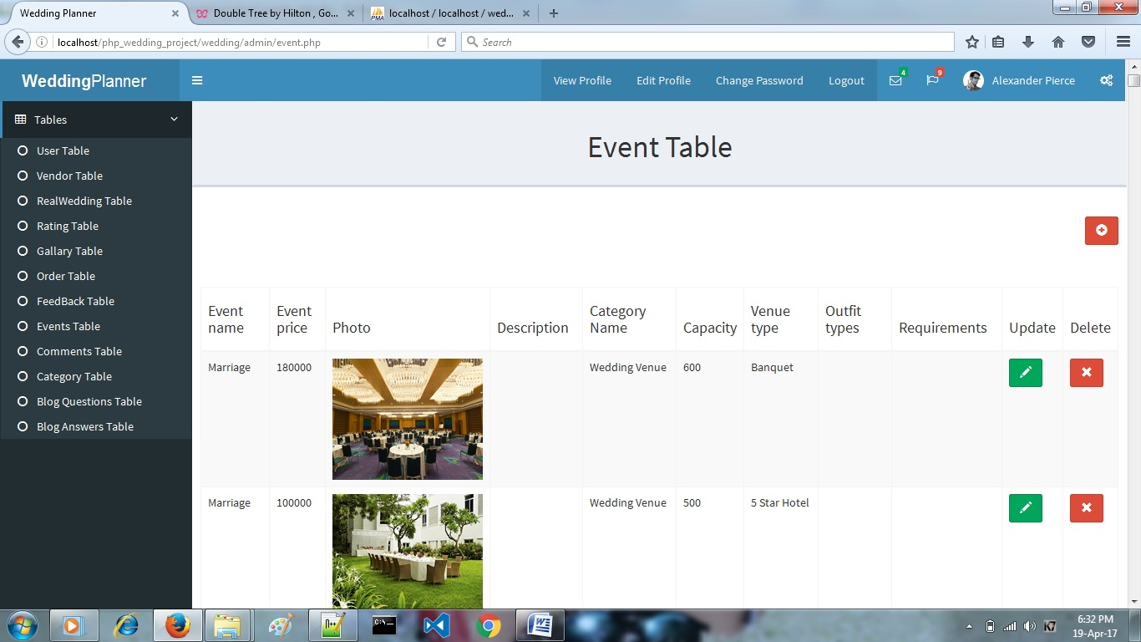

**[13] Comments Page**

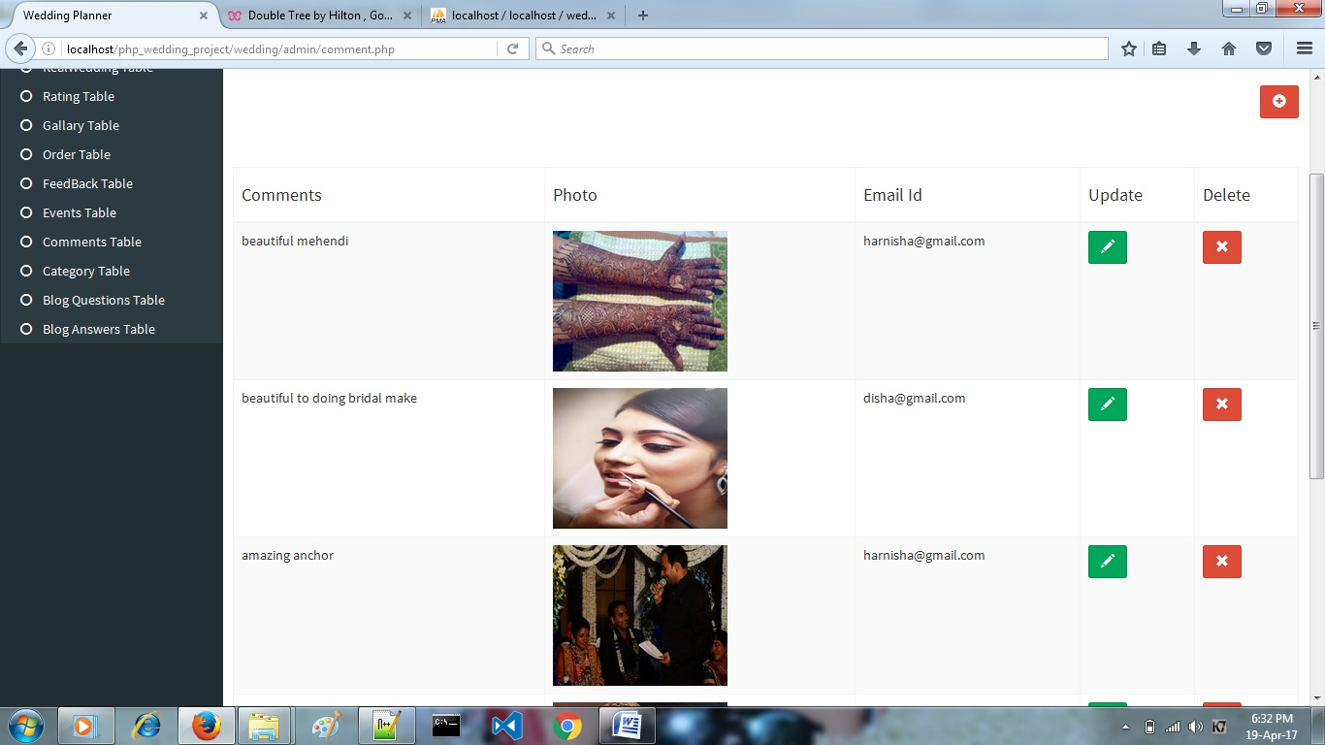

**[14] Category Page**

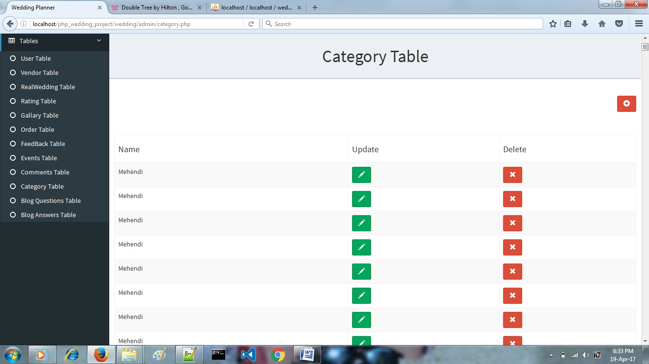

**[15] Blog Questions Page**

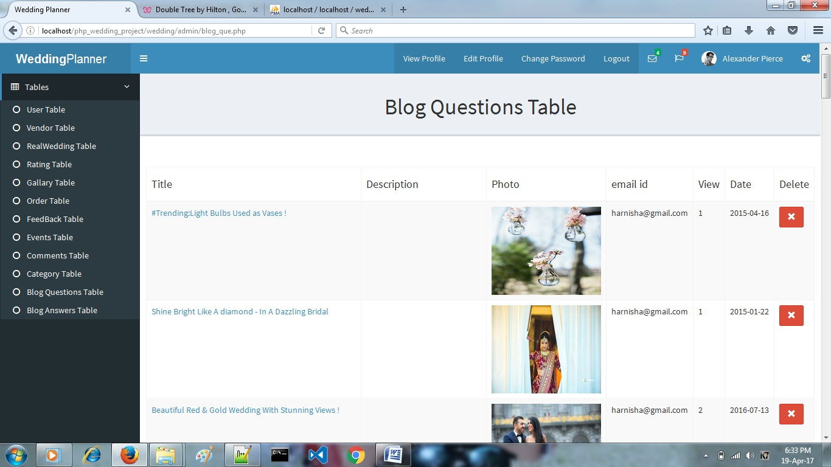

**[16] Blog Answers Page**

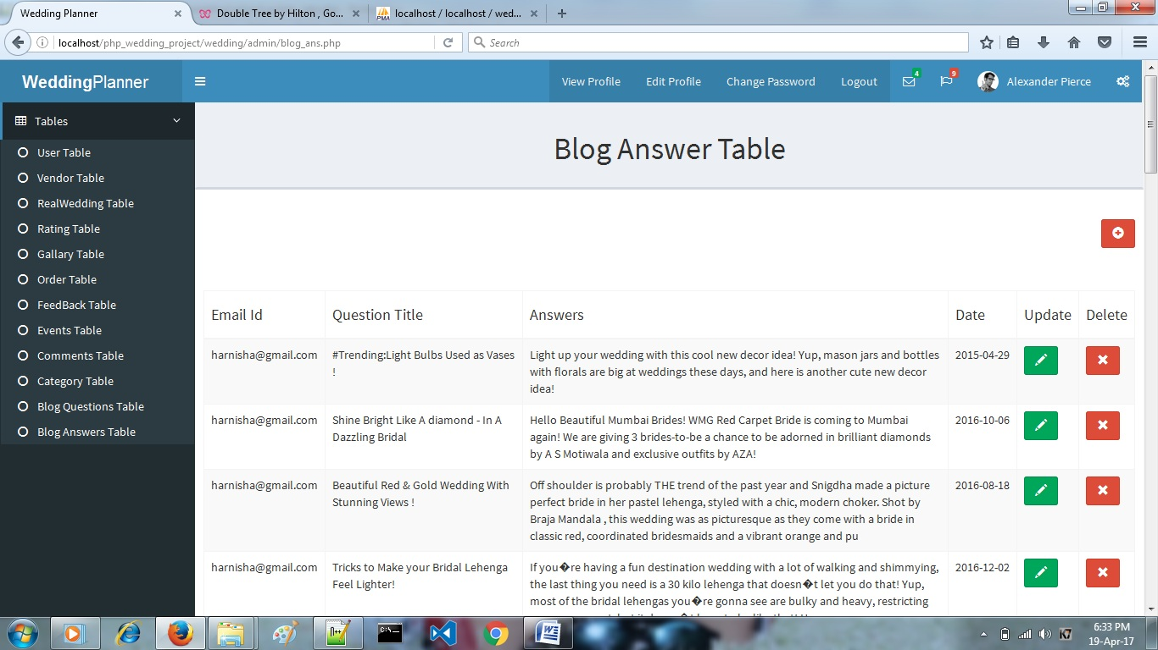

User

**[17] Home Page**

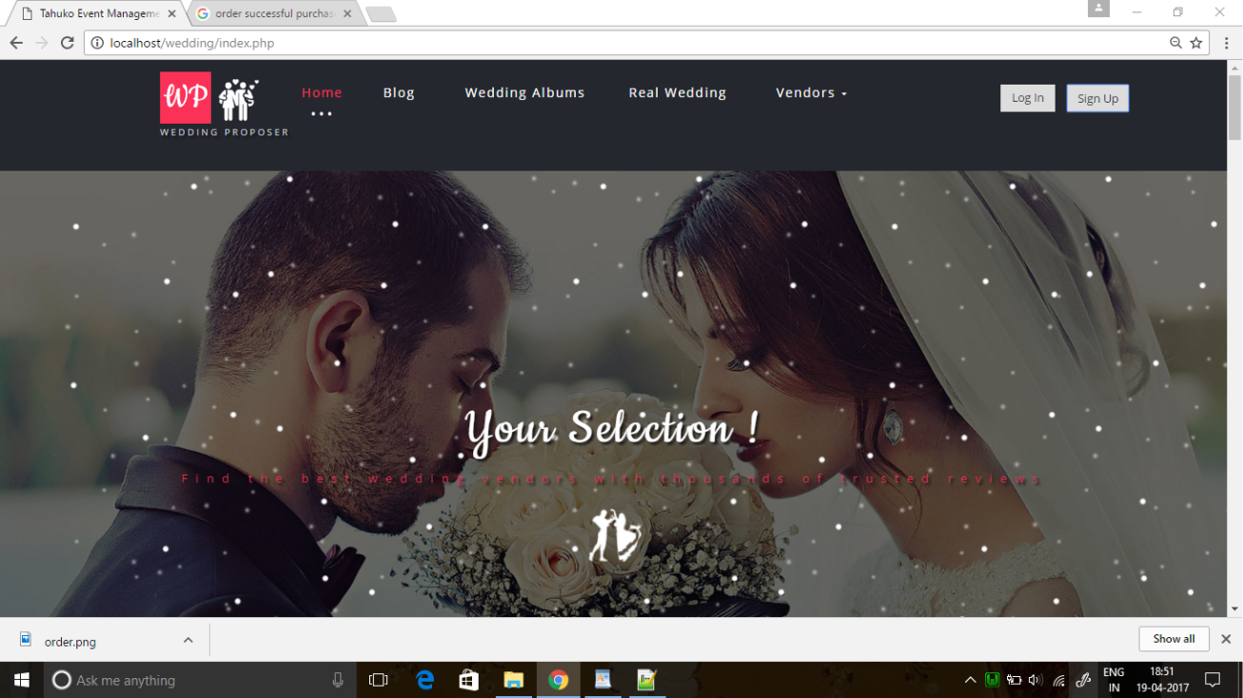

**[18] Login Page**

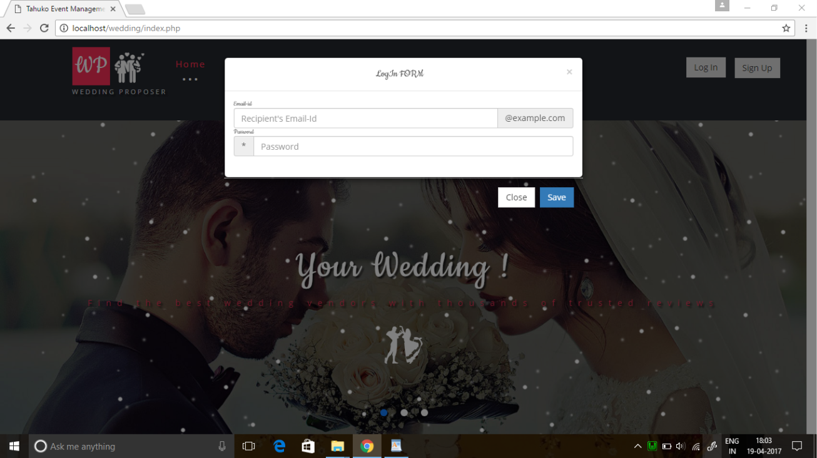

**[19] SignUp Page**

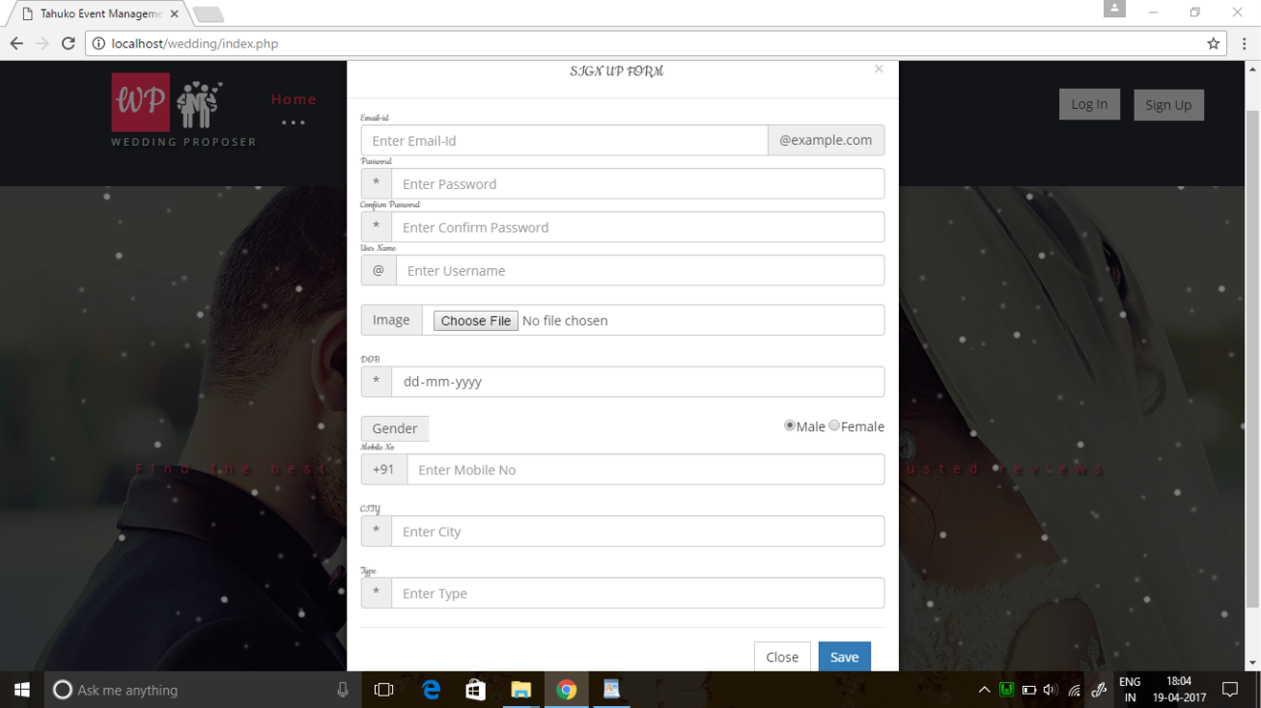

**[20] Home Page**

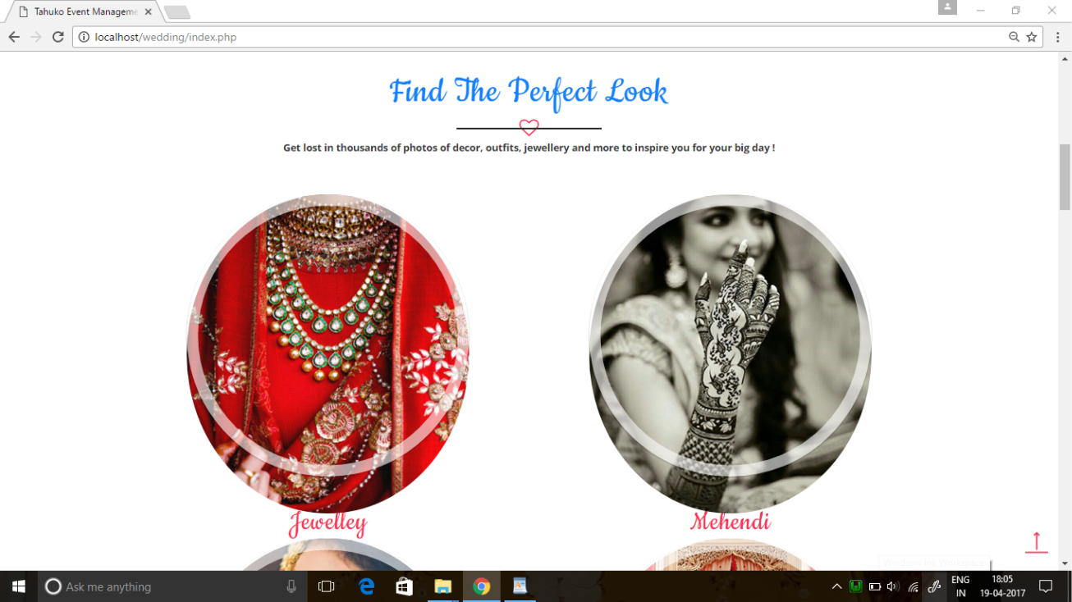

**[21] Home Page**

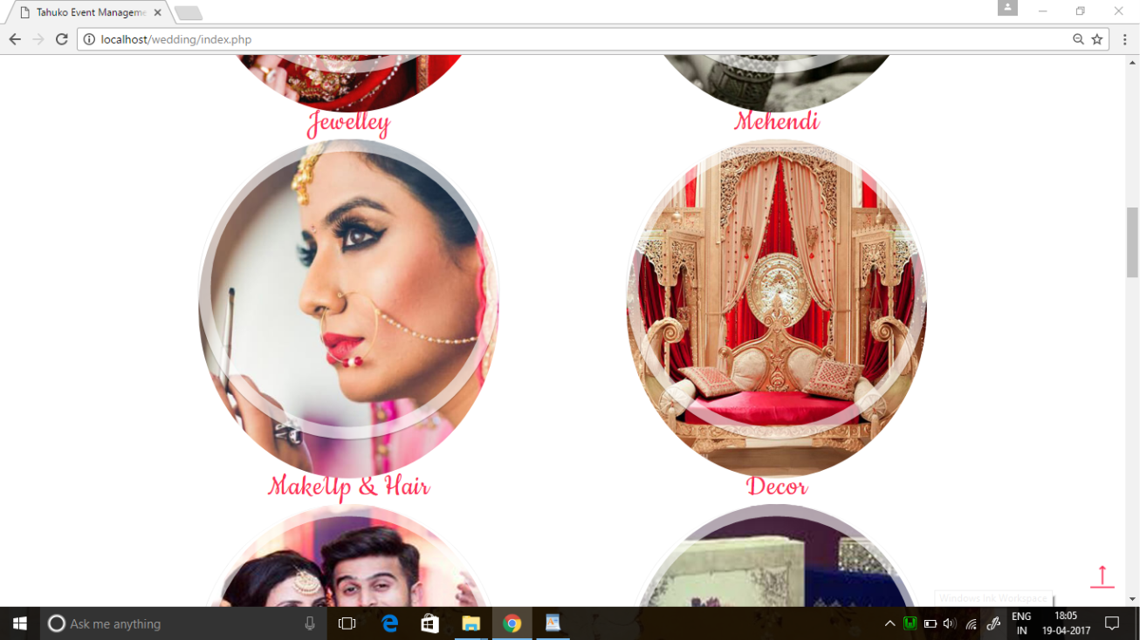

**[22] Home Page**

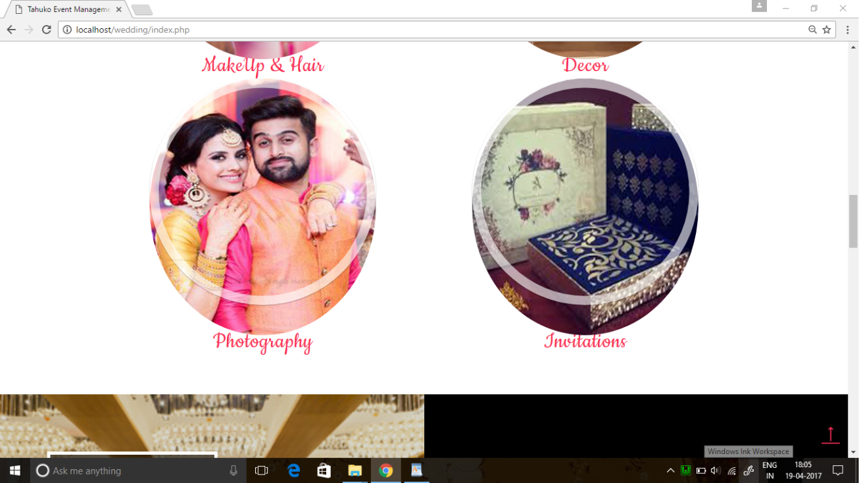

**[23] Home Page**

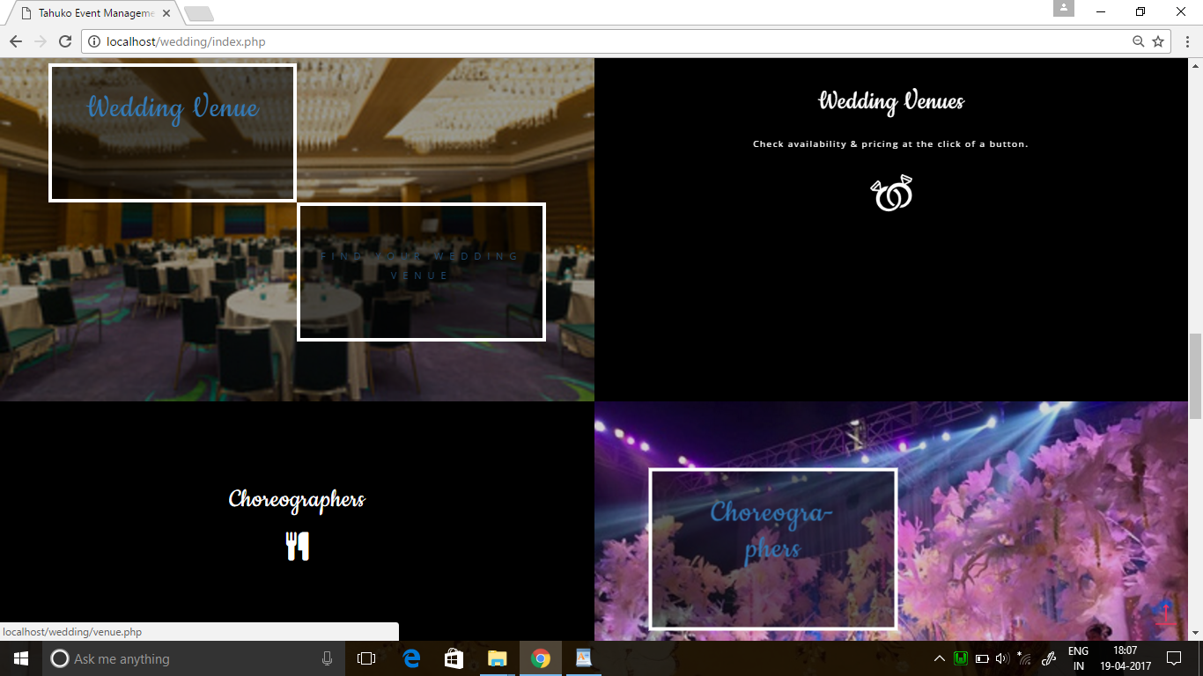

**[24] Home Page**

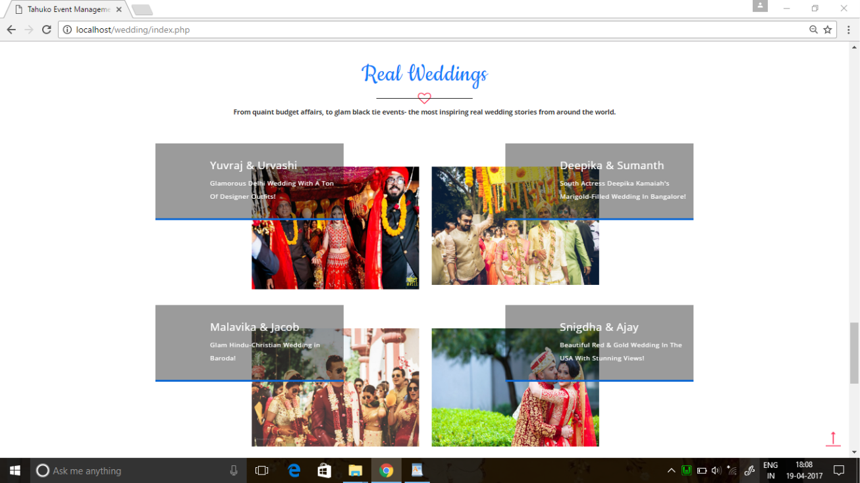

**[25] Footer Page**

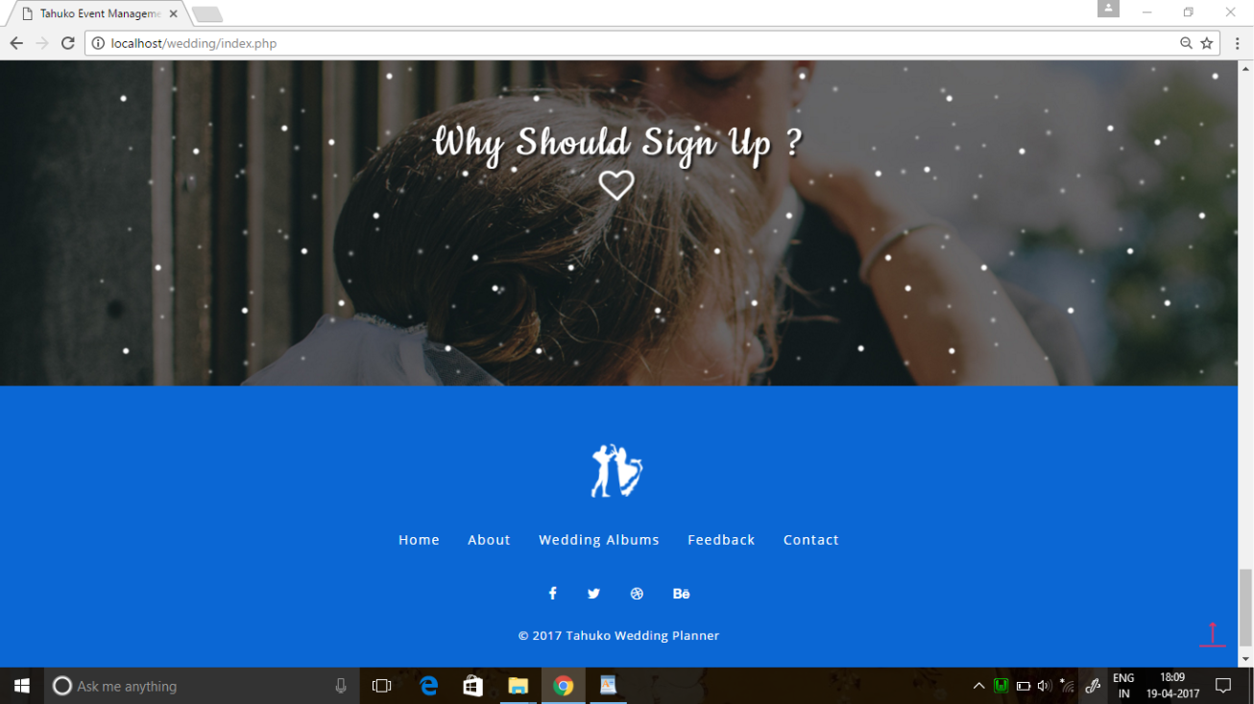

**[26] Blog Page**

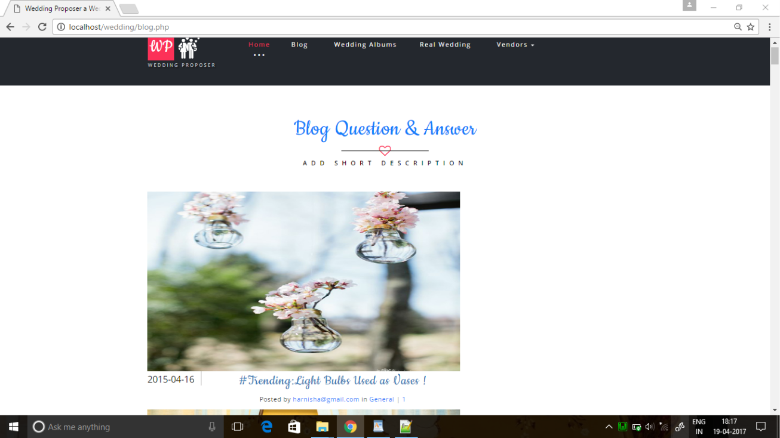

**[27] Blog Answer Page**

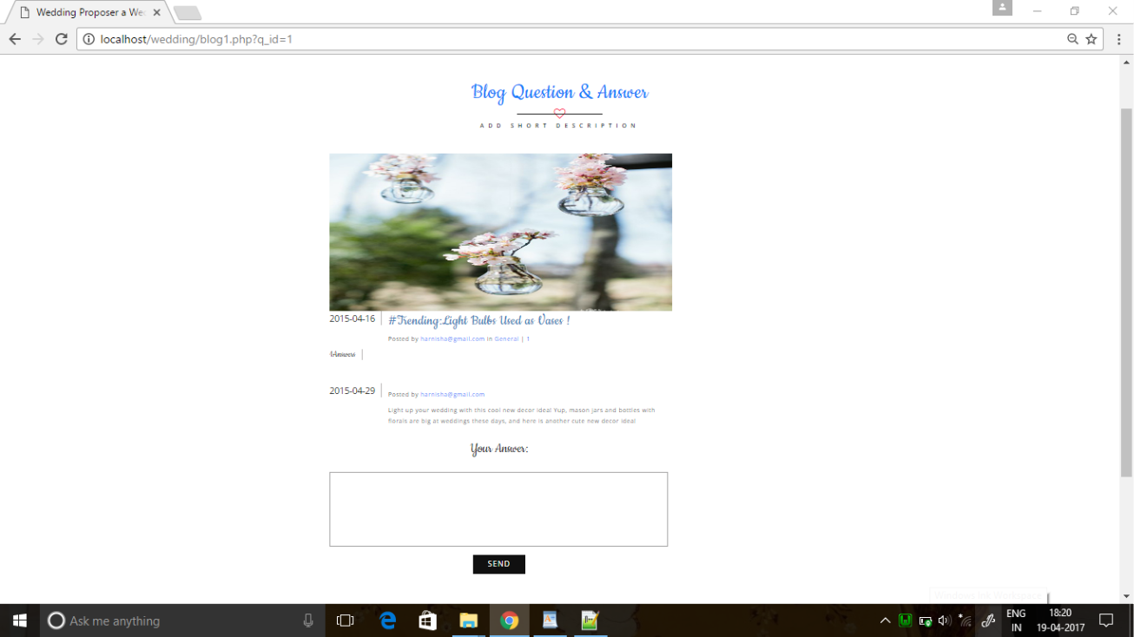

**[28] Wedding Albums Page**

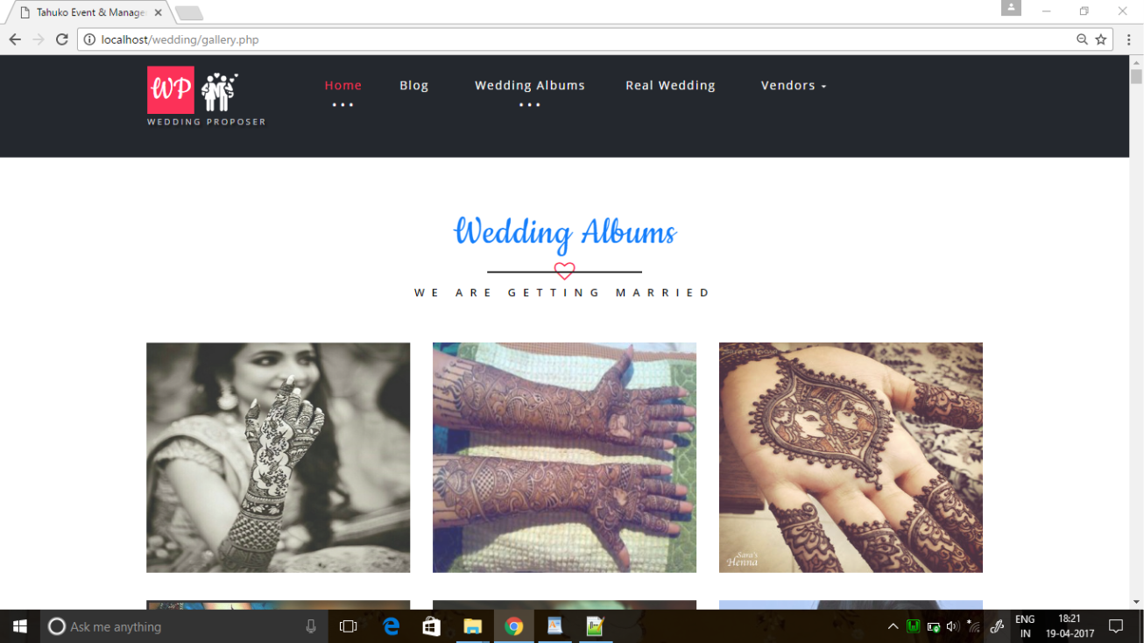

**[29] Real Wedding Page**

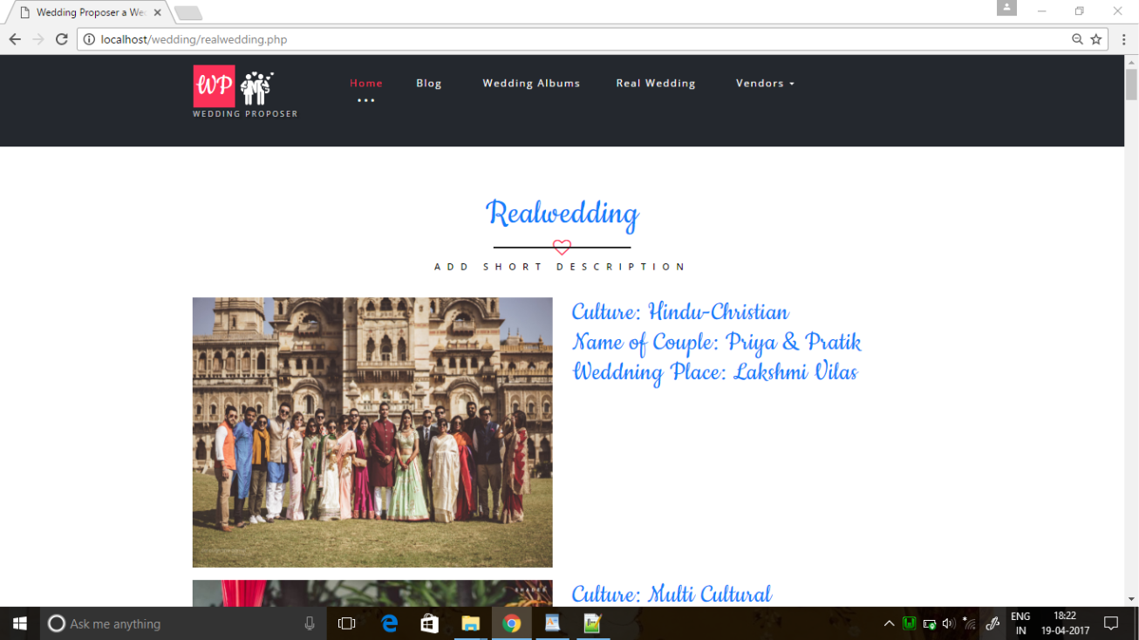

**[30] Venue Page**

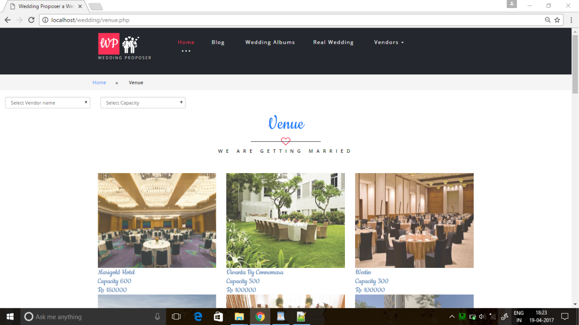

**[31] Photography Page**

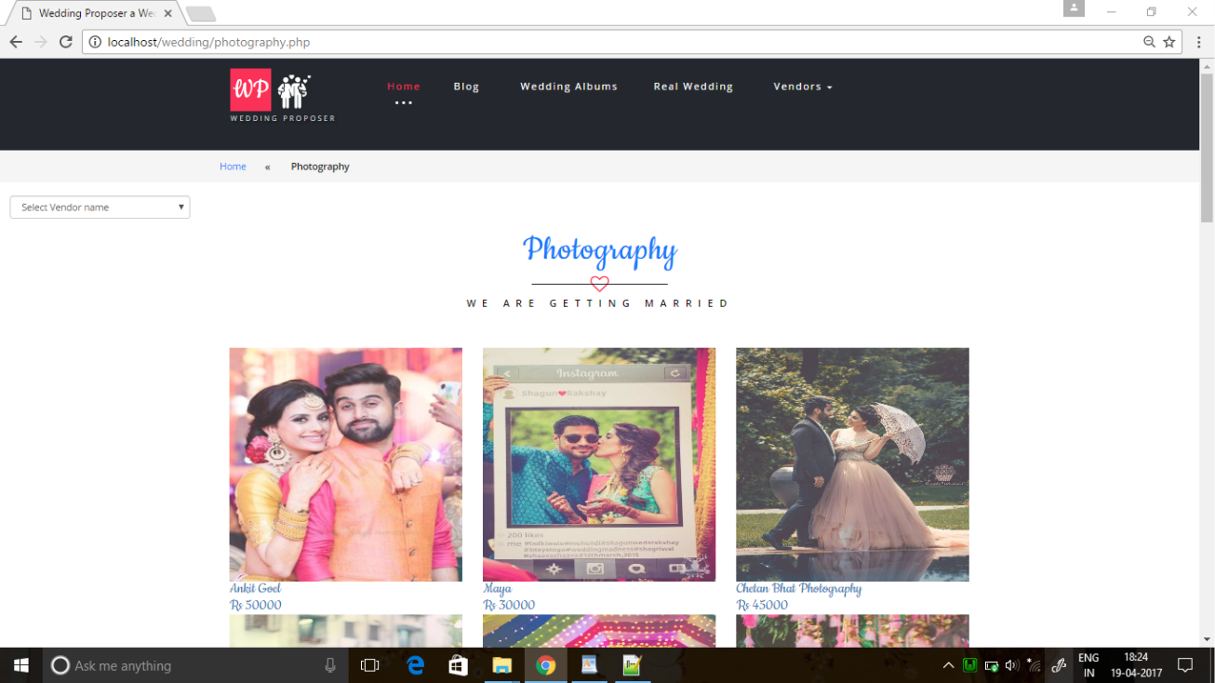

**[32] Makeup Page**

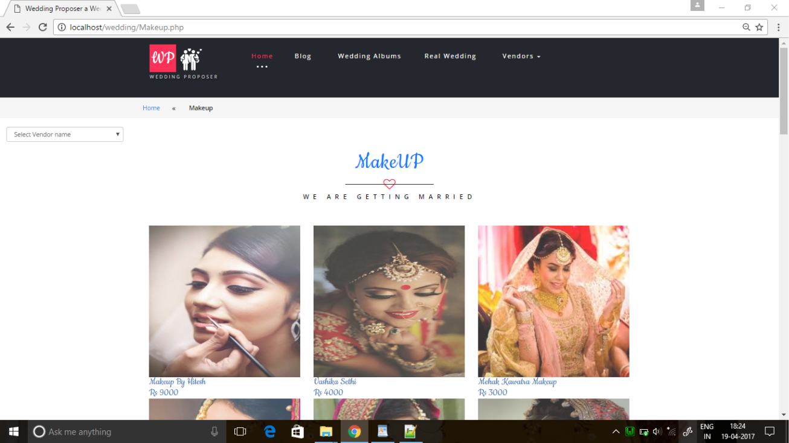

**[33] Mehendi Page**

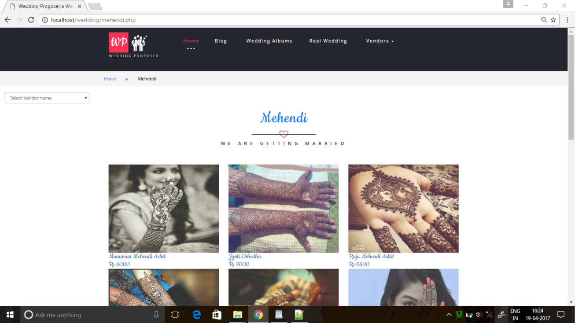

**[34] Catering Page**

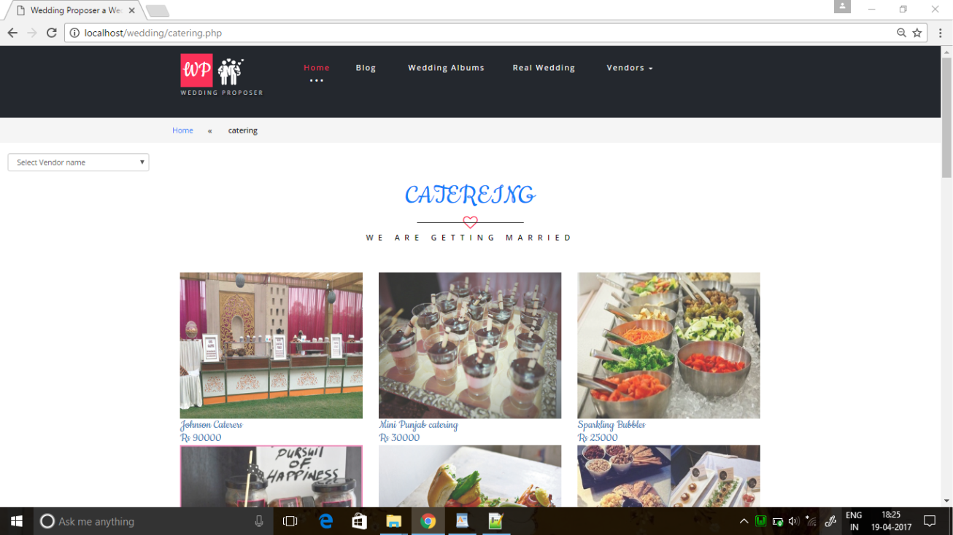

**[35] Invitation Card Page**

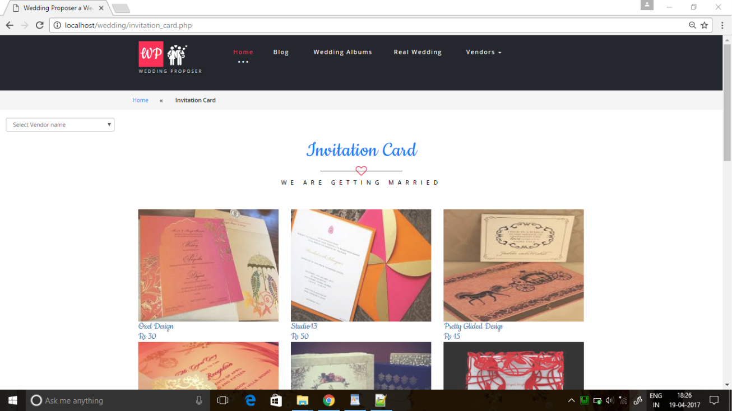

**[36] Decoration Page**

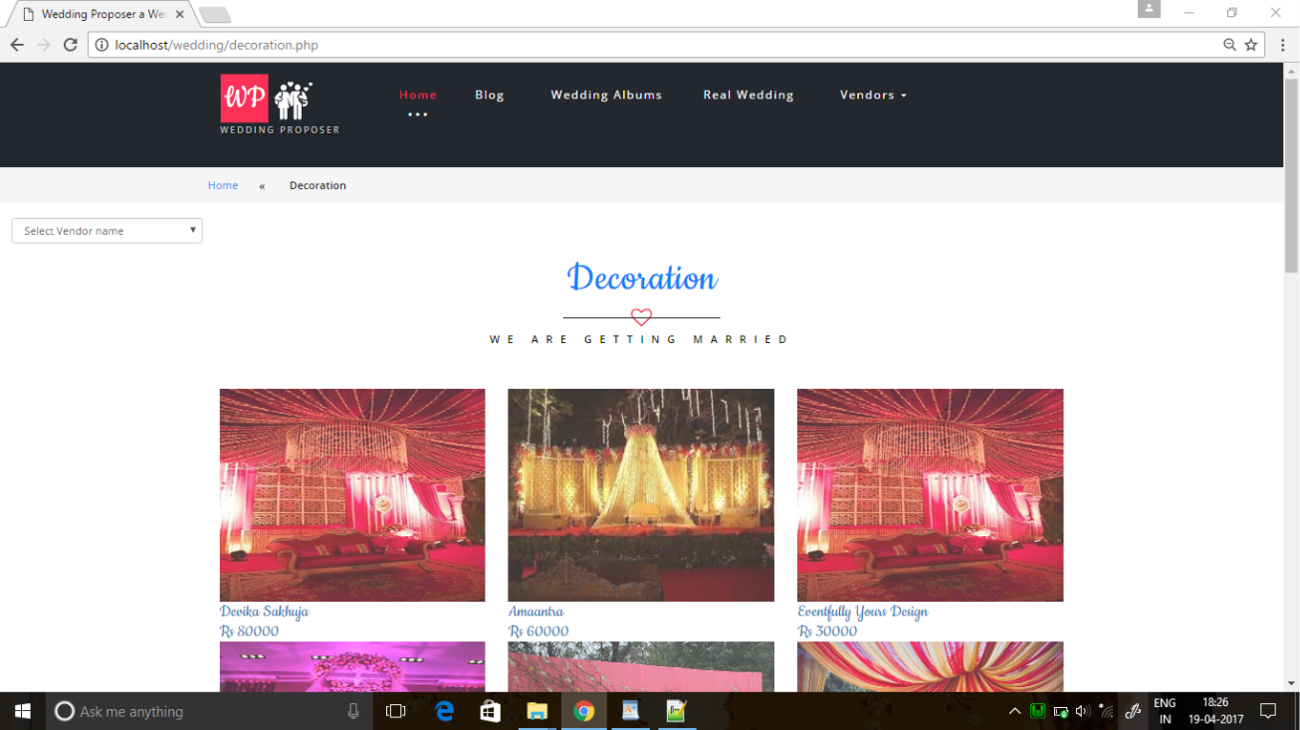

**[37] DJ Page**

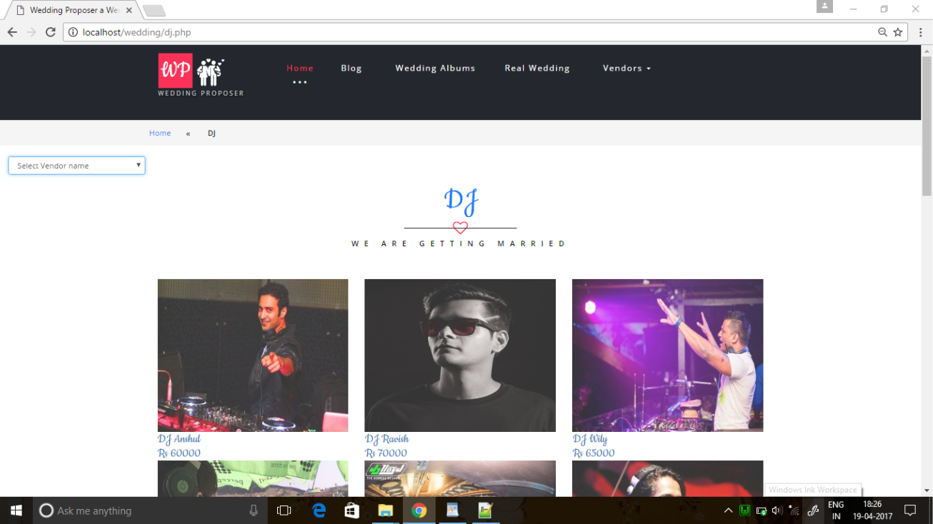

**[38] Choreography Page**

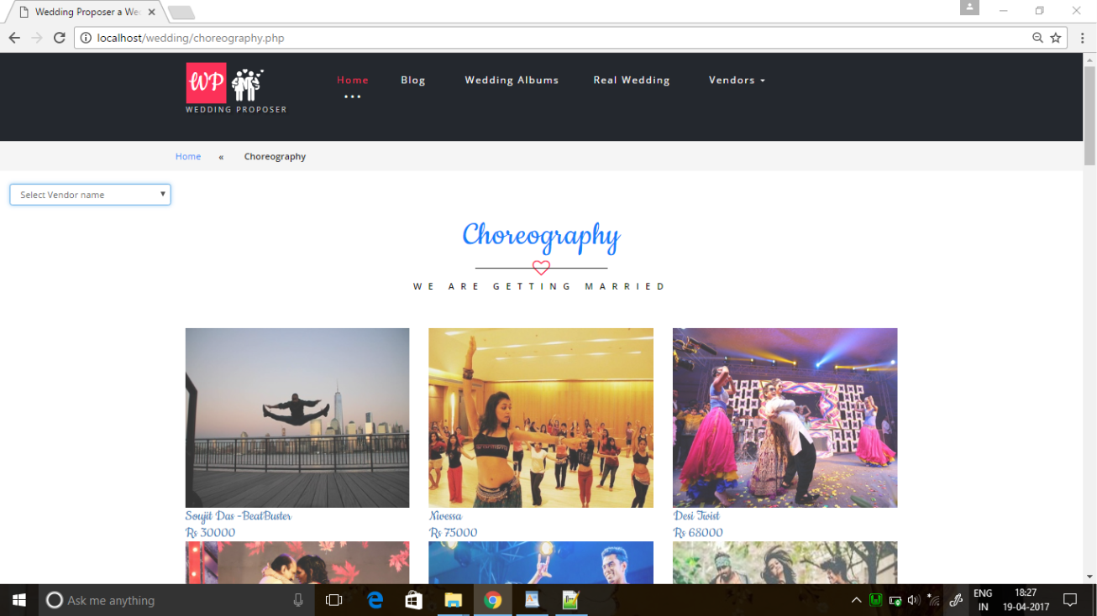

**[39] Entertainment Page**

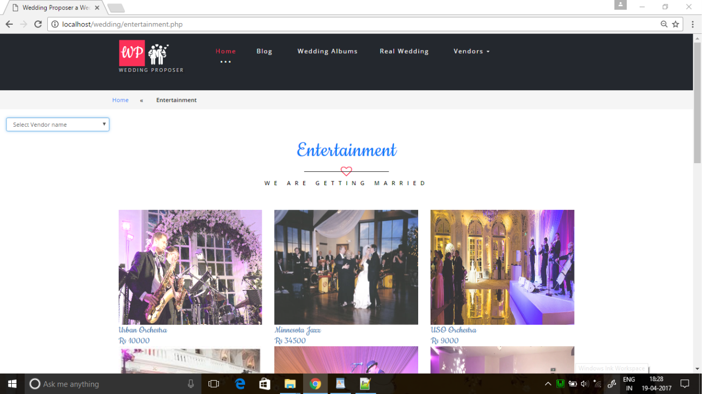 **[40] Transport Page**

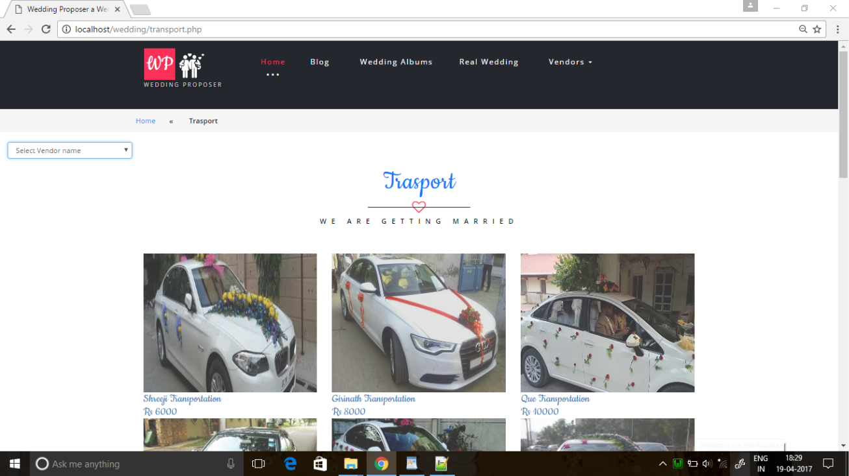

**[41] Lehenga/Jewellery Page**

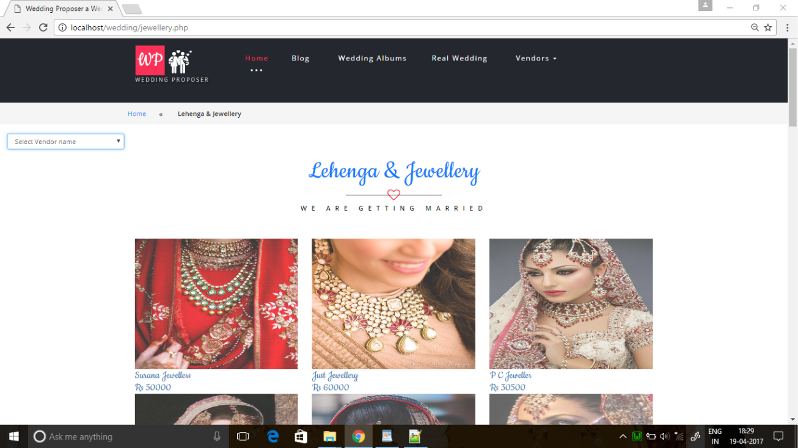

**[42] Band/Bajaa Page**

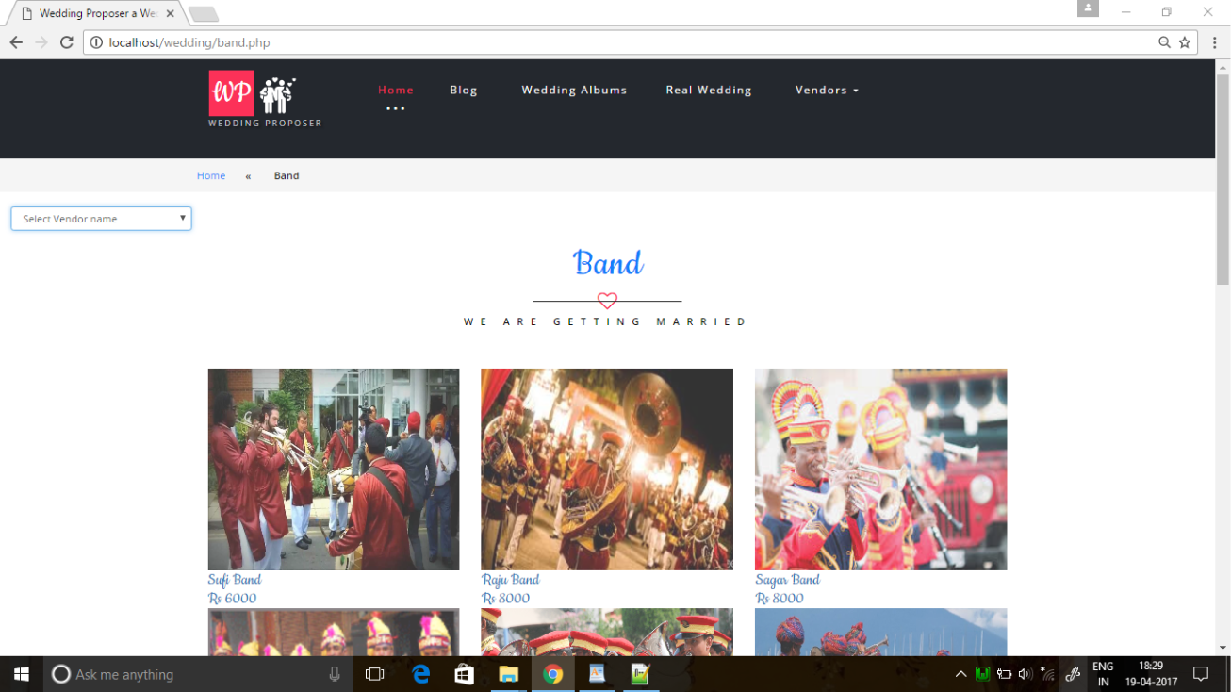

**[43] Pandit/Priest Page**

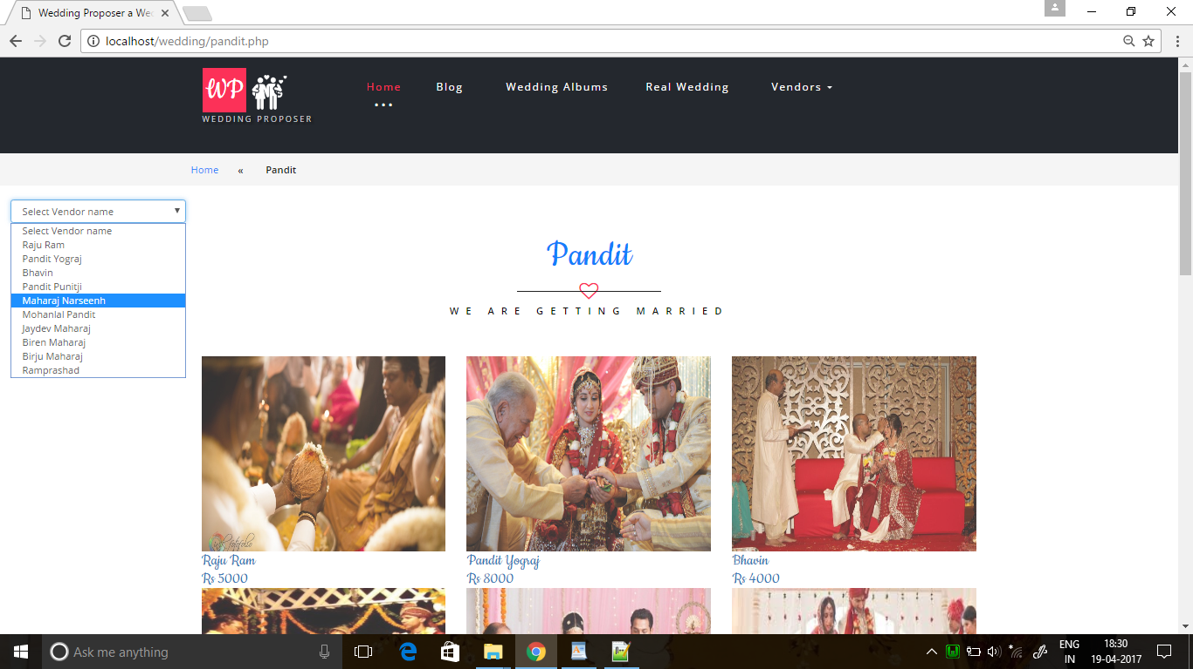

**[44] Anchor Page**

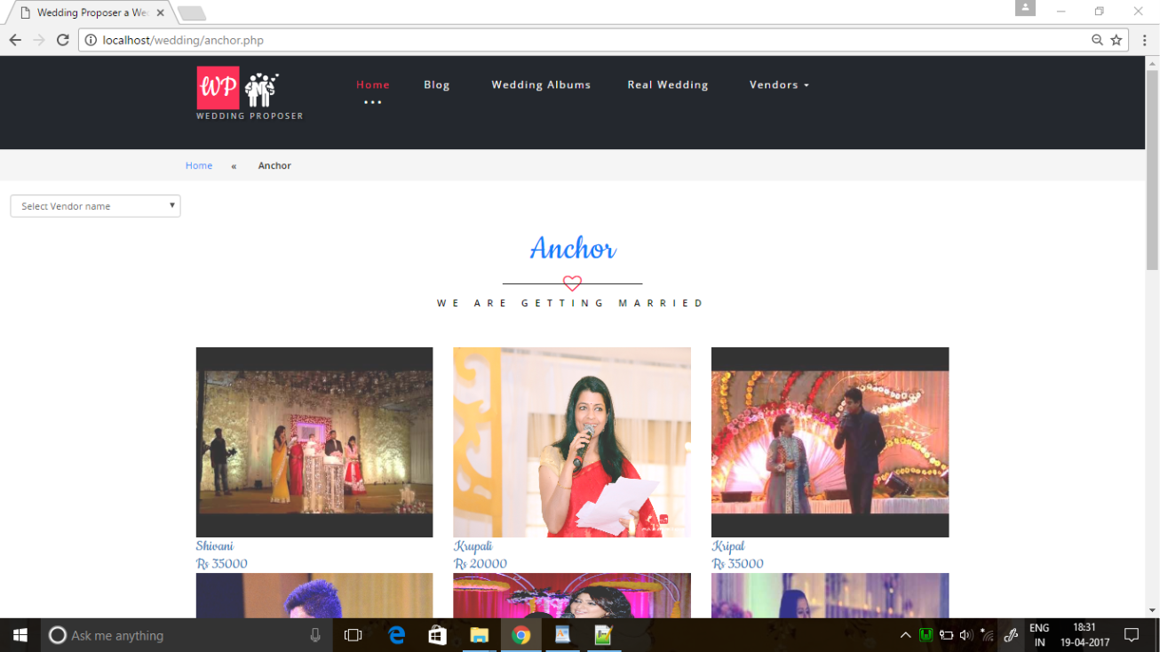

**[45] Add To Cart Page**

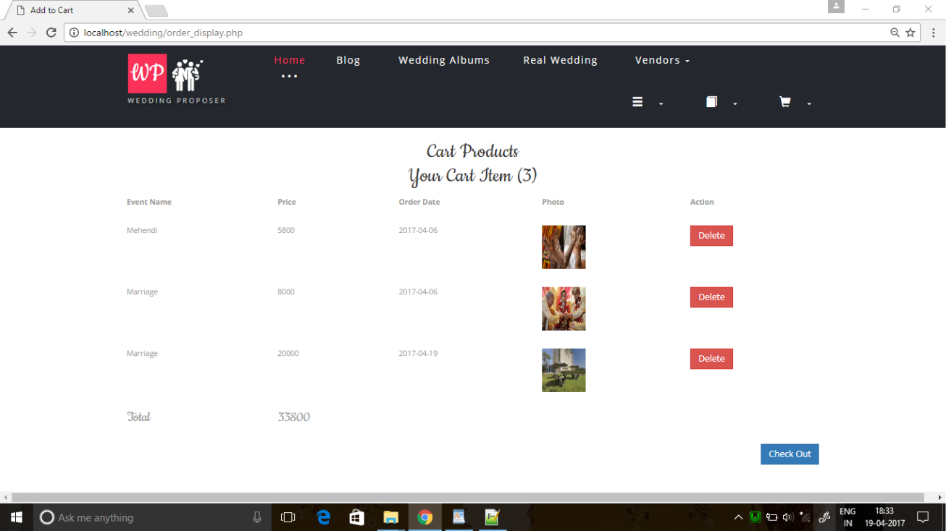

**[46] Payment Page**

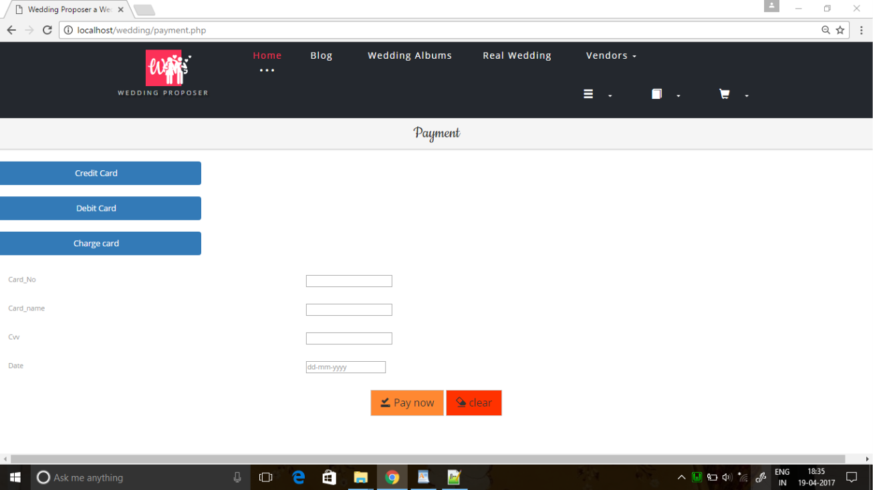

**[47] Boking History Page**

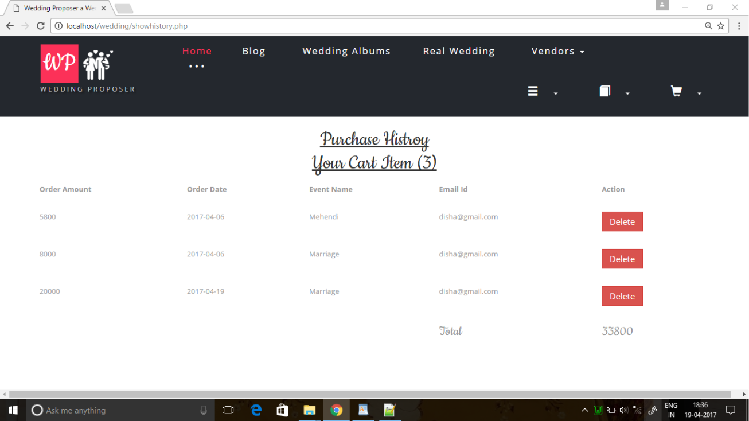

Validation

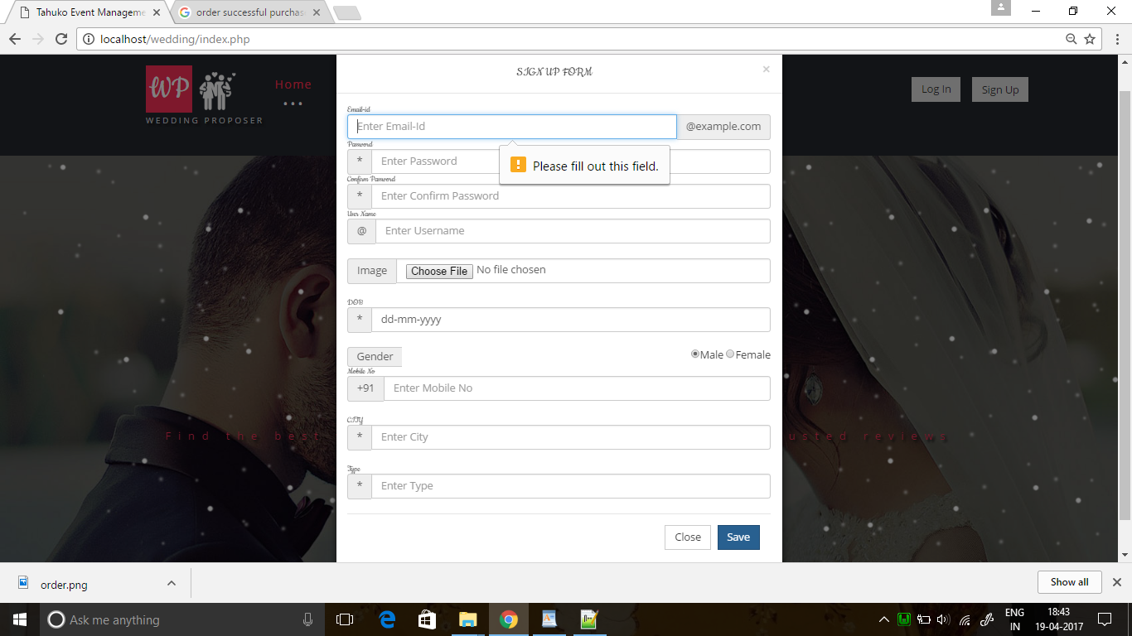

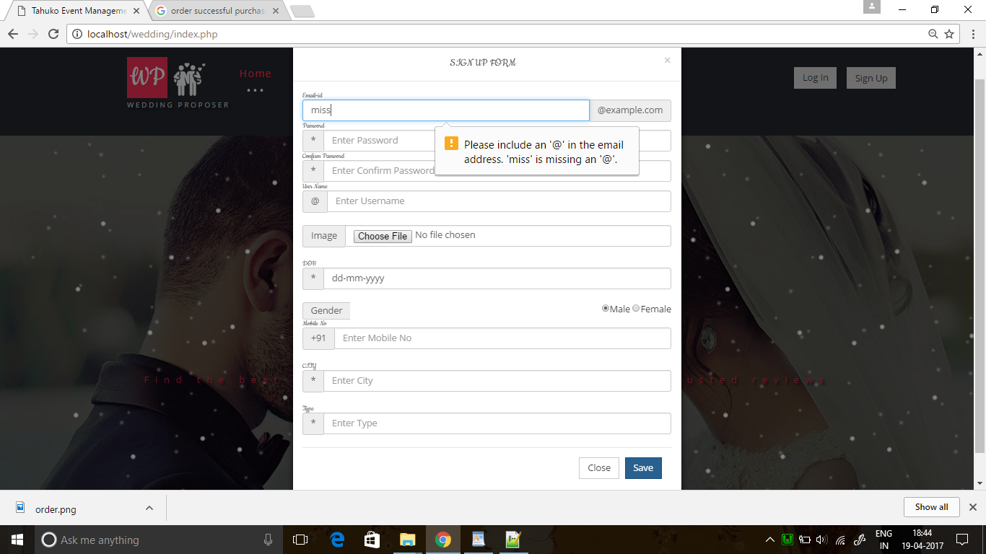

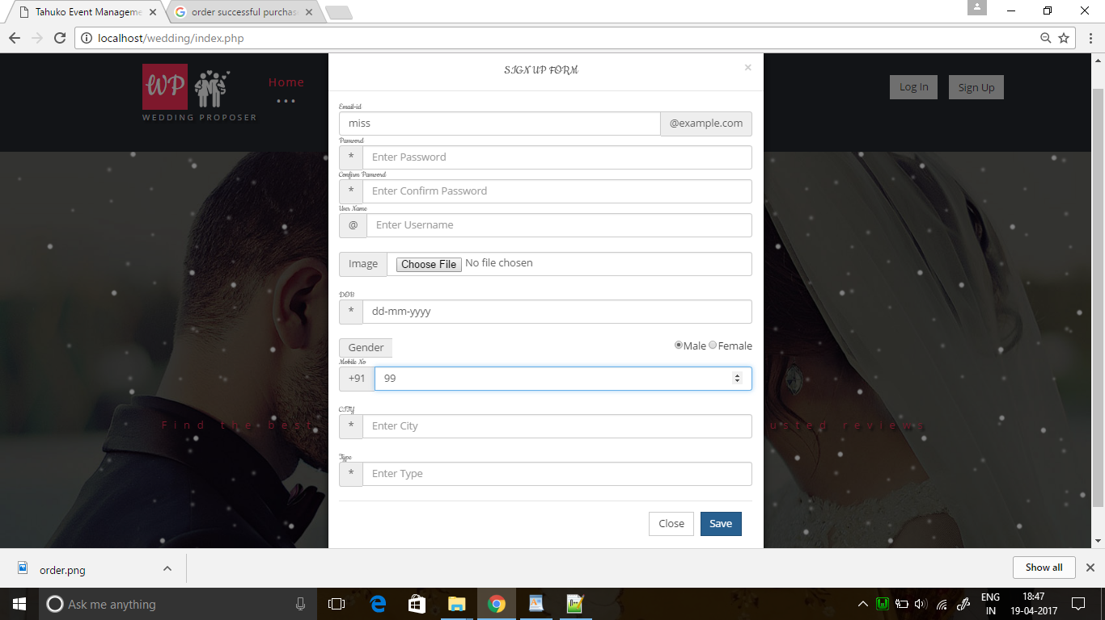

Maintenance

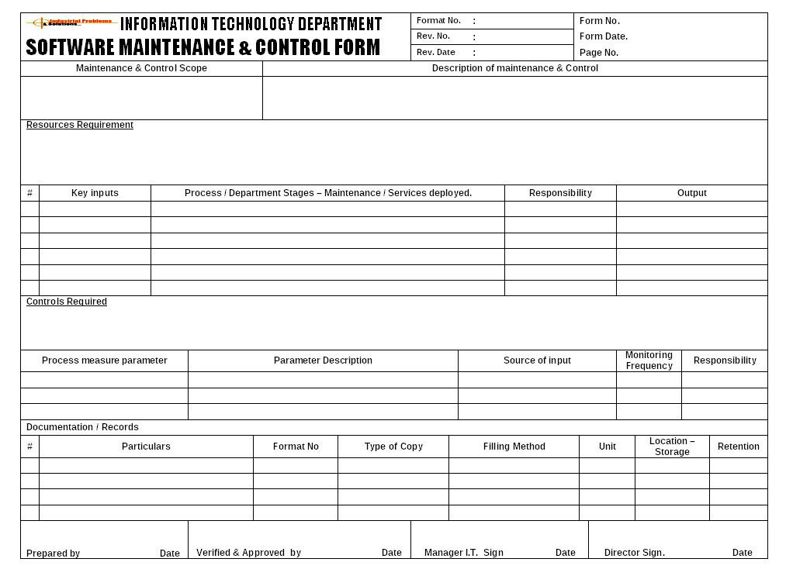

Future Scope

* Wedding planners perform a variety of tasks for couples who have typically already set wedding dates. Although the specific list of tasks changes for each client, wedding planners may make appointments with vendors, provide gown options, suggest wedding themes and troubleshoot setbacks.
* The business side of wedding planning involves staying within budget, ensuring vendors get paid and collecting money from clients. Because they're typically self-employed, wedding planners must also write contracts and be efficient marketers of their business.
* However, special-event centers, wineries, hotels and other hospitality facilities also offer employment opportunities.
* A wedding planner's goal is to design a wedding suited to each couple. They make plans for the outfits, food, theme, and other aspects of the wedding, working with their client's suggestions. Wedding planners can be employed by a company or work freelance; no education is required but short training classes are strongly recommended.

Bibliography

**Books :-**

1. HTML DHTML JAVAScript

By Ivan Bayross

2. Analysis & Design of Information

By James A Senn

3. SOFTWARE ENGINEERING A practitioner's Approach

By Roger S. Pressman

**Websites :-**

1. <www.bandbaja.com>

2. [www.Weddingz.in](http://weddingz.in/)

3. [www.SantoriniGlam Weddings.com](http://www.santoriniglamweddings.com/?gclid=CPbj-vTWrtMCFdcmvQodiysHyw)